Text Drivers 2024/25- EYFS
 | Week 1 | Week 2 | Week 3 | Week 4 | Week 5 | Week 6 | Week 7 | Week 8 | Other possible texts
Aut 1 | Induction | Baseline  YOU CHOOSE  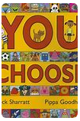 | Baseline  YOU CHOOSE | THE DINOSAUR THAT POOPED A PLANET!  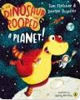 | THE VERY HELPFUL HEDGEHOG  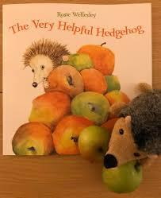 | Black History Month  COMING TO ENGLAND  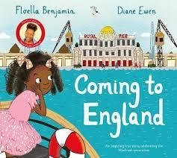 | WE’RE ALL WONDERS  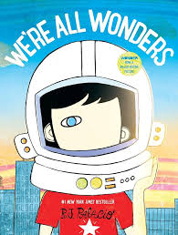 |  | Ruby’s Worry  The Train Ride  Peace at Last  Look Up!  Giraffe’s Can’t Dance  Funny Bones  The Rainbow Fish  The Colour of Us  The Ugly Duckling
Aut 2 | Guy Fawkes  BONFIRE NIGHT  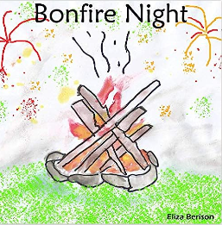 | Diwali  RAMA AND SITA  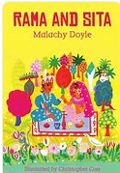 | LITTLE RED HEN  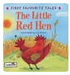 | St Andrew’s Day  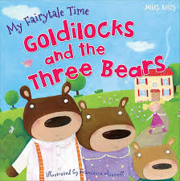 | ONE SNOWY NIGHT  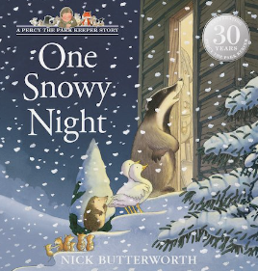 | Christmas Story  THE JOLLY CHRISTMAS POSTMAN  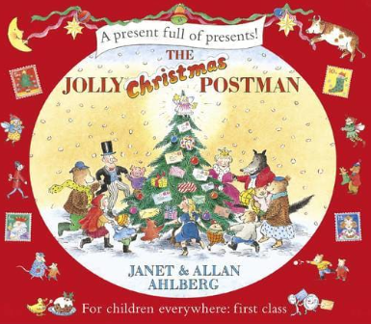 |  |  | The Little Hedgehog  Hairy Maclary  Percy the Park Keeper  Handa’s Surprise  Pumpkin Soup  Snowman  Nativity
Spr 1 | BABOUSHKA  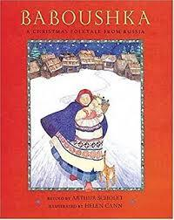 | OWL BABIES  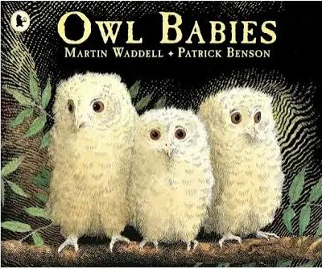 | THE VERY HUNGRY CATERPILLAR  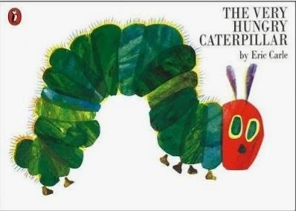 | THE TIGER WHO CAME TO TEA  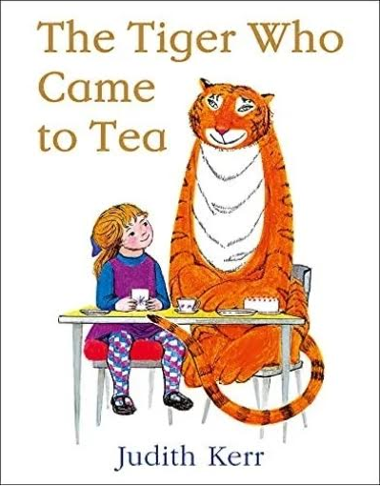 | Chinese New Year | THE GREAT RACE  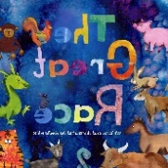 |  |  | The Three Kings  David Attenborough
Spr 2 | Lent | St David’s Day  JASPER’S BEANSTALK  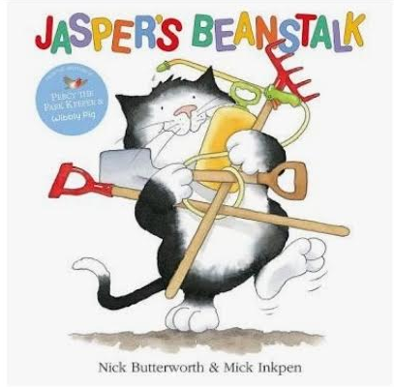 | WHATEVER NEXT!  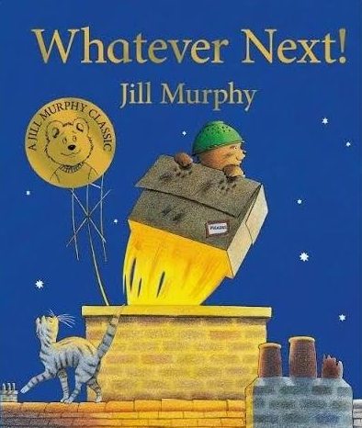 | LOOK UP!  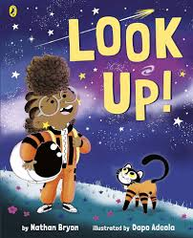 | THE WAY BACK HOME  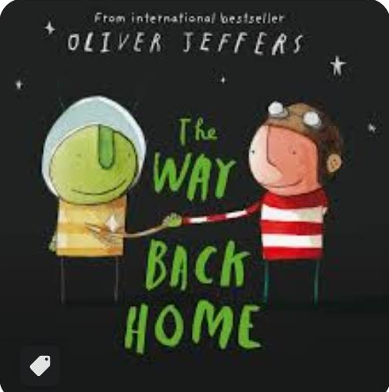 | 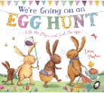  Holy week |  |  | Once Upon a Star  Laura’s Star  Let’s Go Outside  Wild
Sum 1 | ROBIN HOOD  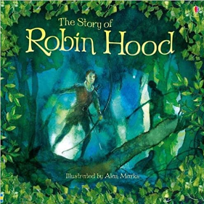 | ZOG  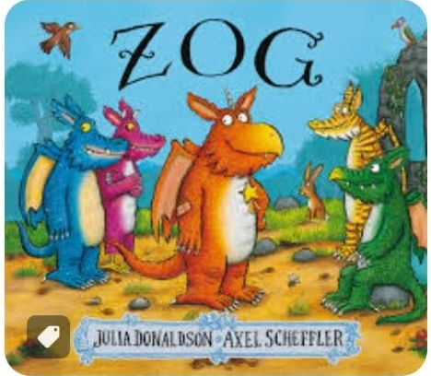 | ZOG AND THE FLYING DOCTORS  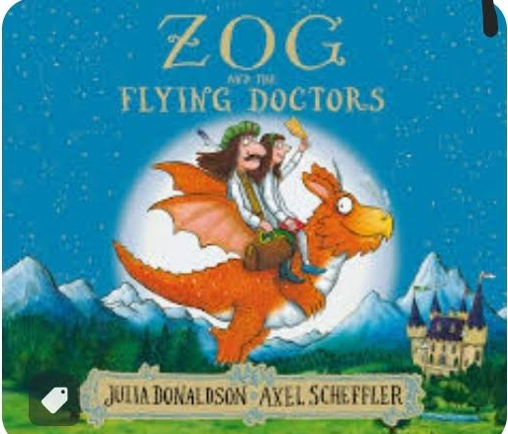 | St George’s Day  THE KING’S PANTS  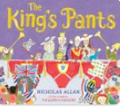 | THE KNIGHT WHO WOULDN’T FIGHT  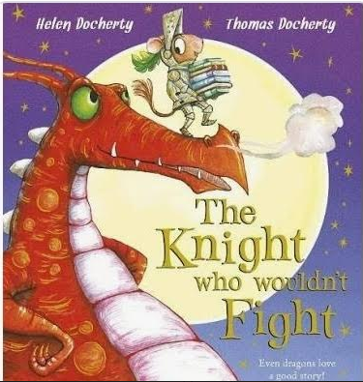 | IN THE CASTLE  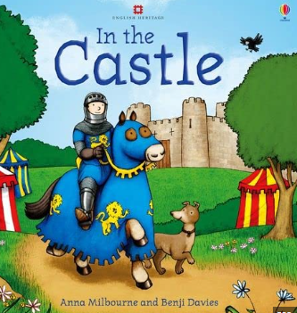 |  |  | Little People Big Dreams – King Charles  Cinderella
Sum 2 | 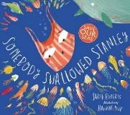  SOMEBODY SWALLOWED STANLEY | THE SEA SAW  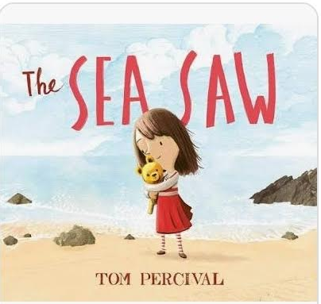 | TIDDLER  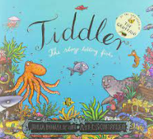 | THE BIG BEACH CLEAN UP  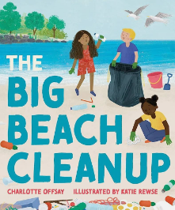 | ONLY ONE YOU  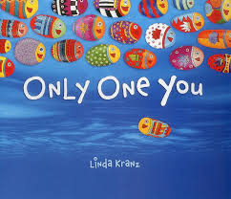 | AT THE BEACH  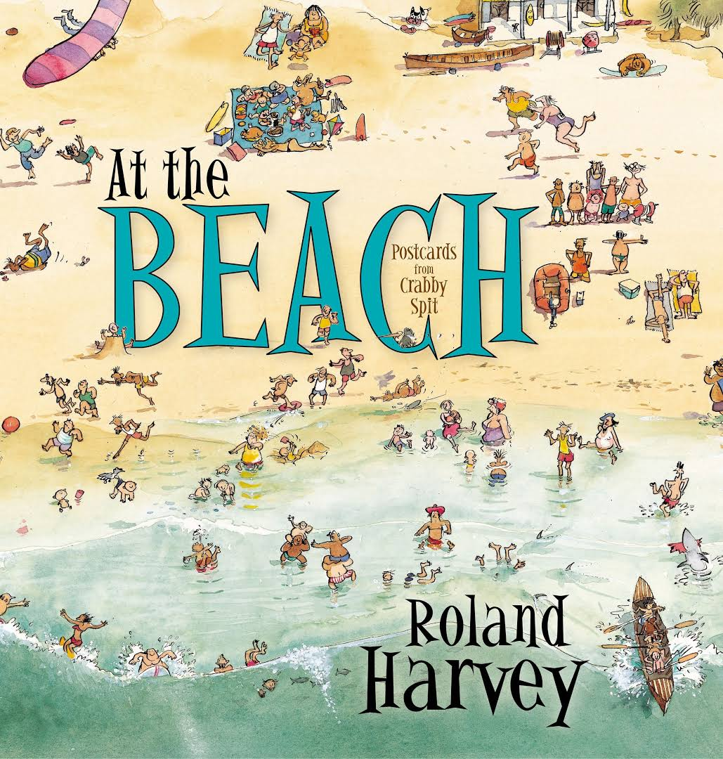 | CLEM AND CRAB  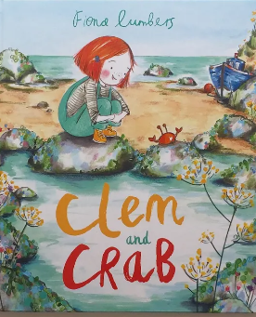 | Snail and the Whale | Under the Sea (non-fiction)  Emma Jane’s Aeroplane

NB: GAPS IN PLAN TO ALLOW FOR CHILD LED LEARNING

