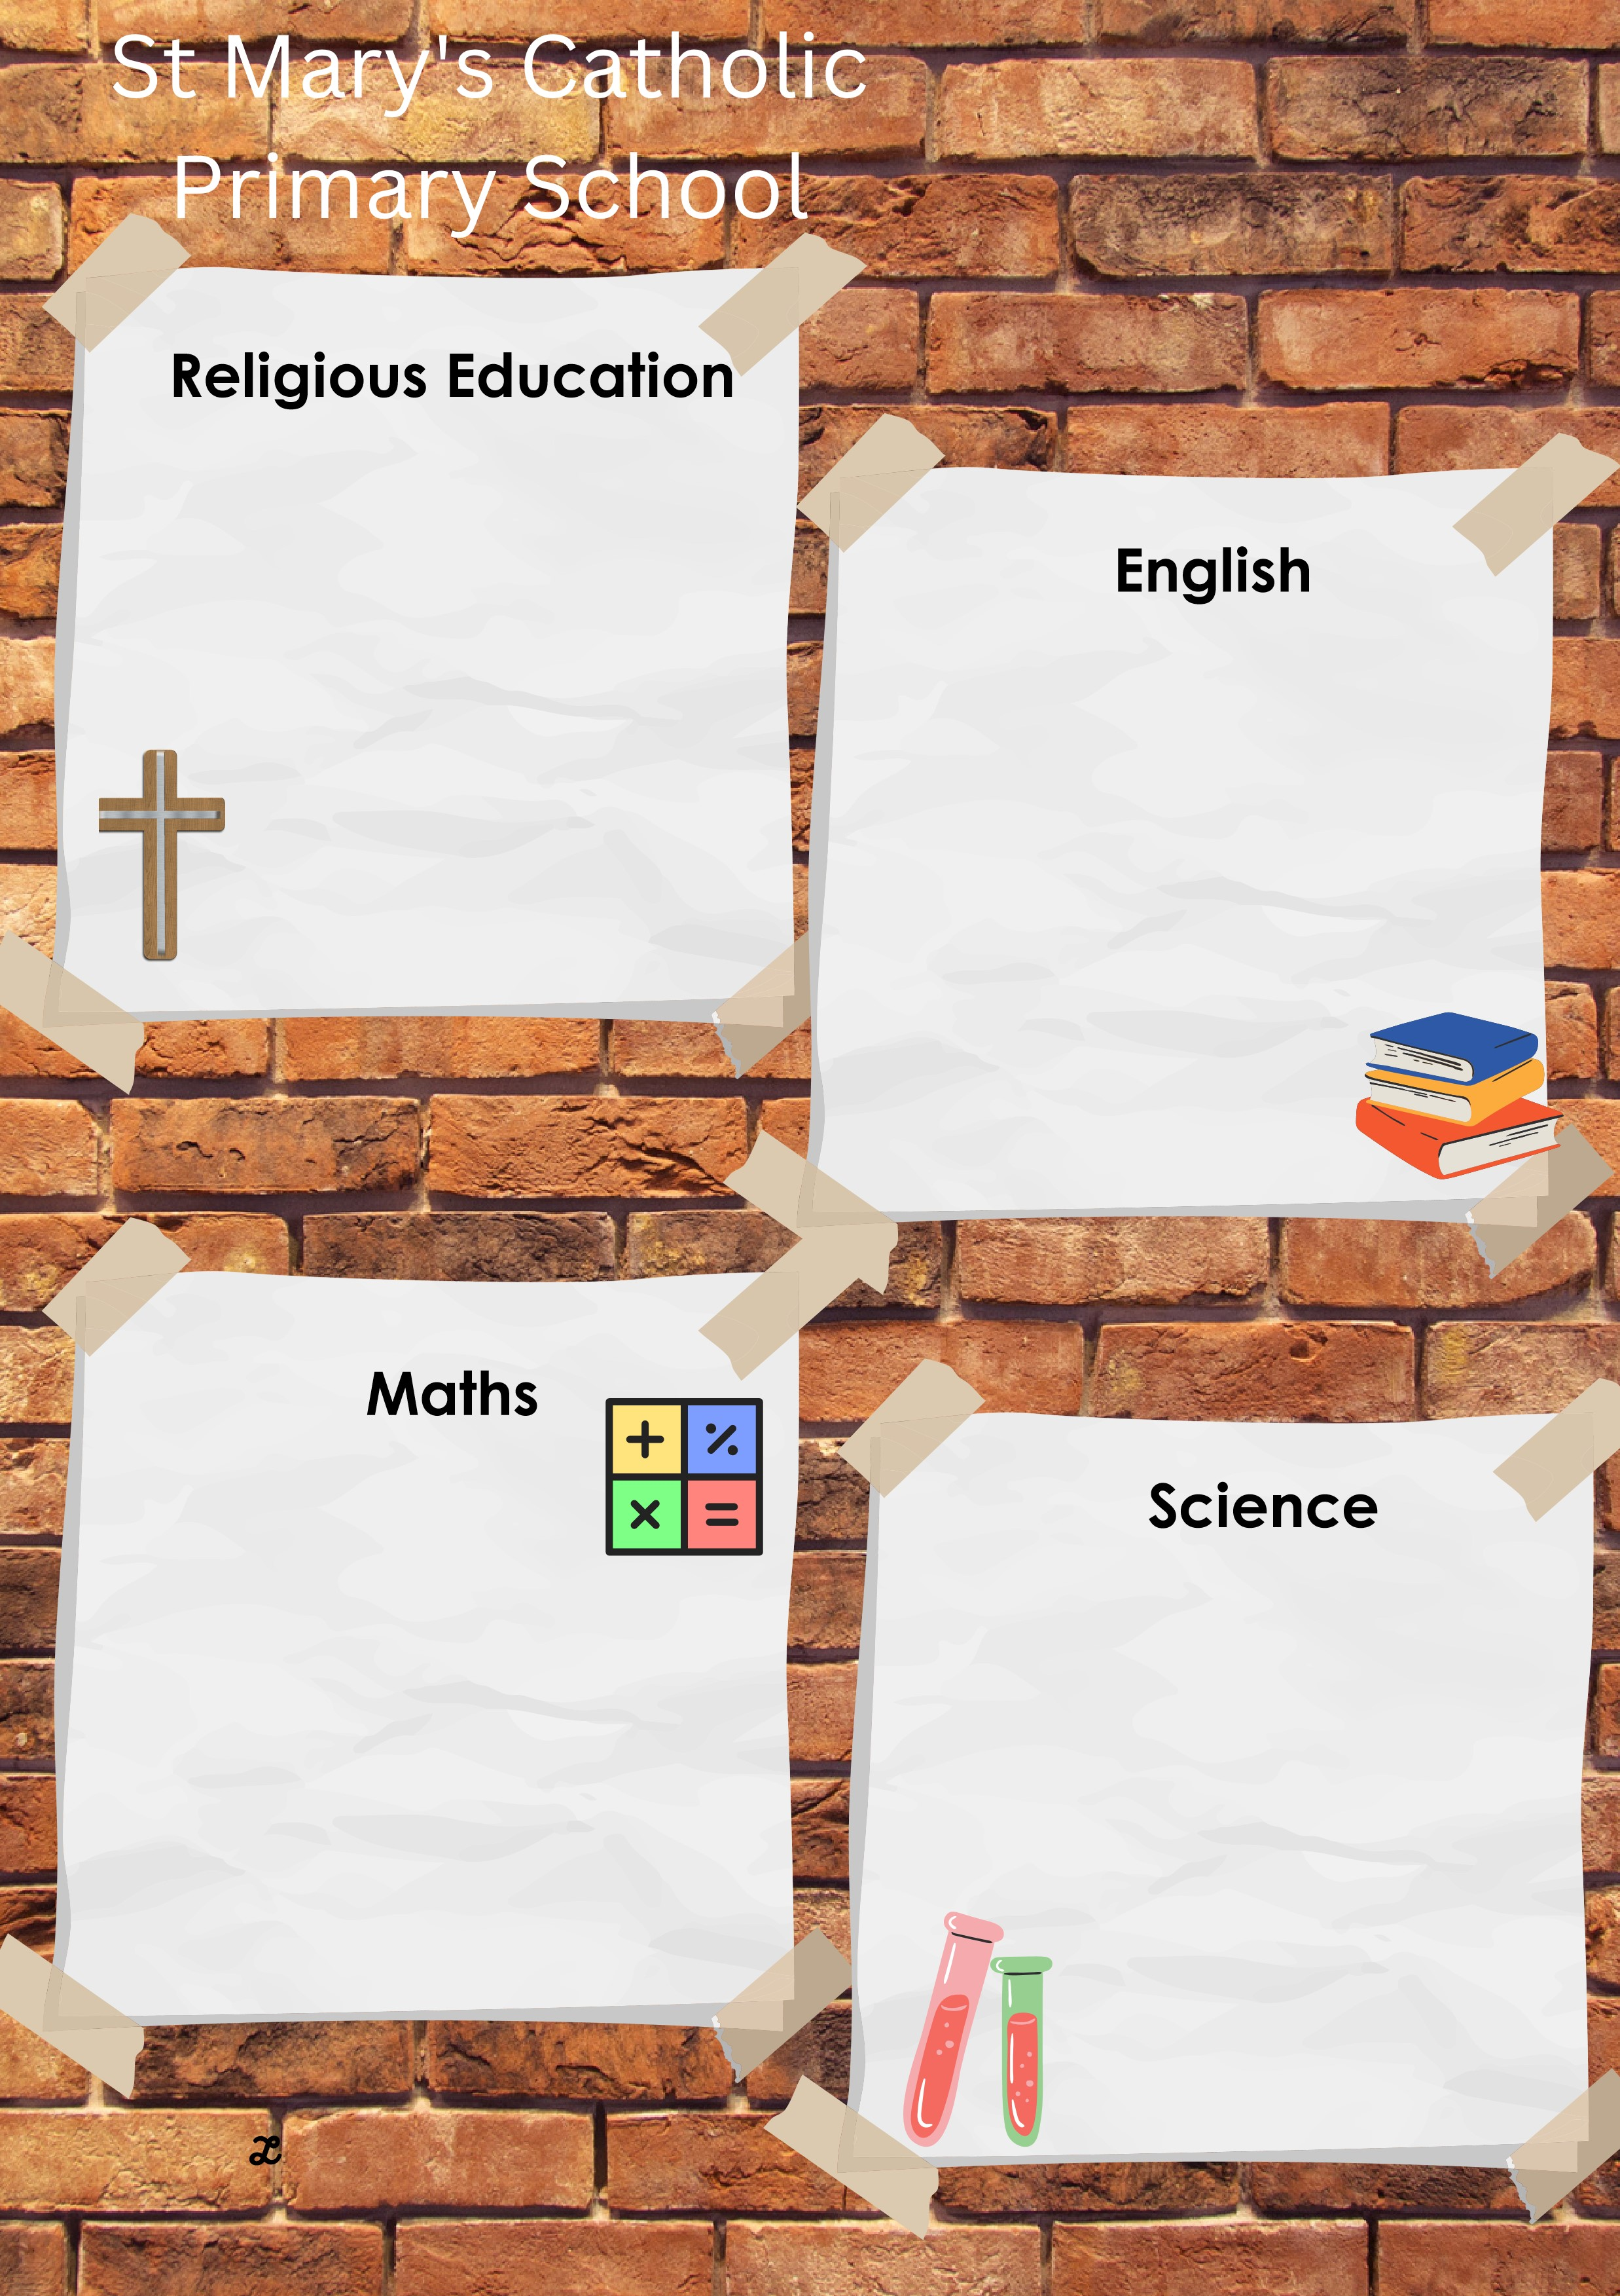
This half term we will be reading:
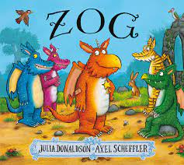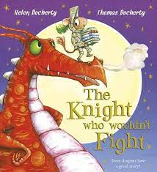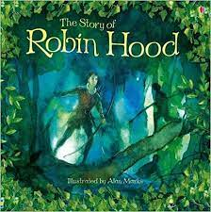
We will be looking at stories from the past and will be retelling a story with actions and picture prompts as part of a group. We will be focusing on rhyming words within our stories.

We will re-read our books to build our confidence in word reading, fluency and our understanding and enjoyment.

Through the use of acting and retelling stories, we will explain the main events of a story and will draw pictures of characters / events / settings in a story. We will also include labels, sentences or captions.

This half term we will be focusing on continuing to develop our skills through real life, everyday scientific experiences. We will do this through:

- Welly Walks: describing what we hear, feel and see.
- Compare what we have observed with previous experiences.
- Learn and remember the names of some local plant and animal species and habitats.

This half term we will be focusing on numbers to 20.
We will be working on the following skills through adult led activities and within our continuous provision:
- Subitising
- Counting
- Composition
- Sorting and matching
- Comparing and ordering
- Number bonds 10-20
- Counting patterns beyond 10
- Spatial reasoning

This half term will be learning all about Easter, and we will discuss and respond to the story of the resurrection. We will build excitement about finding out about the empty tomb. Easter is the most important and joyous of seasons!
Our multi-faith element allows us to start to look at Hinduism as a religion.

The key scriptures we will study are:
The Easter story in the children’s Bible.

LIVE LOVE BELIEVE
Summer 1 in EYFS
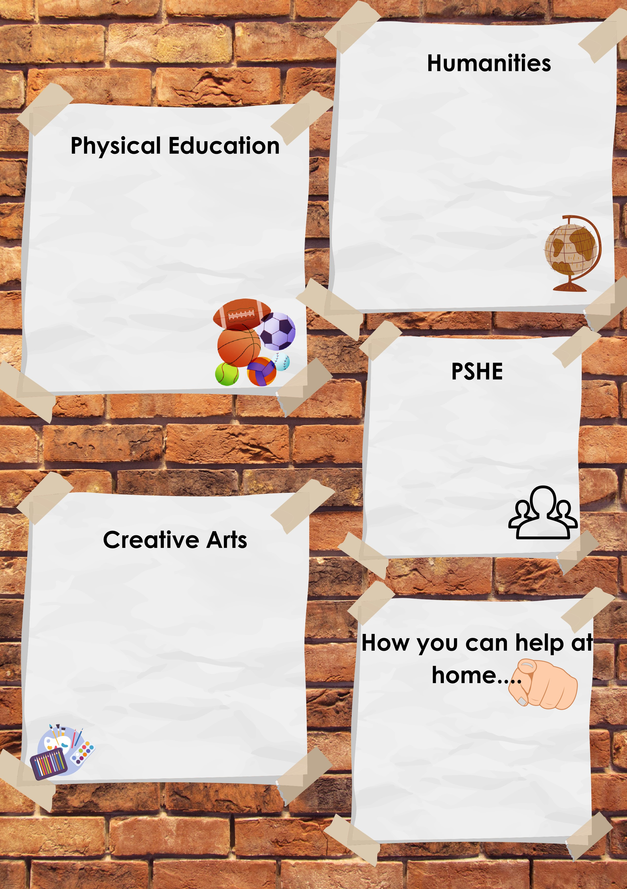
Following the life to the full curriculum, we will be focusing on the module called created to live in a community, where we will be introduced in a very simple way the concept of the Trinity, where God is three-in-one and each part loves the others and loves us. We will come to understand that as we are made in the image of God, we are designed to love God and love one another in our wider communities too. Through the story of Jesus feeding the 5000 with just the humble offering of a small boy, we will learn that our loving actions can be used by God to do incredible things

Reading at least 3 times a week with your child – allowing them to become fluent and confident readers is key!
Phonics – using bug club phonics, complete the phonics games and practice of the daily sound and become fluent in blending sounds together.
Personal development – keep working on being independent with clothes and shoes

Our Art focus this half term we will continue to develop our artistic knowledge and skills through adult led activities and daily continuous provision.
Art is promoted using:
● Access to art and mark making materials throughout the continuous provision.
● Large- and small-scale painting, collage and junk modelling materials are available.
● Traditional and non-traditional drawing and writing tools.
● Self portraits.
The focus of our PE lessons this half term is:
Indoor: Swimming. We will begin our aquatic journey by visiting waterside swimming pool to learn about water safety and to gain confidence when being in the water.
Outdoor: Athletics. We will be focusing on continuing to develop our gross motor skills, by running and jumping and setting ourselves targets in speed and length.
Please make sure that we have the correct clothing and footwear for these lessons.

This half term we will be learning all about the History of Castles in Medieval Madness!
We will be verbally sequencing traditional tales from around the world and suggest what might happen next.

We will be visiting Carisbrooke Castle and then will write about our experience of a castle.

We will talk about the differences between castles from the past and present day castles.

LIVE LOVE BELIEVE

