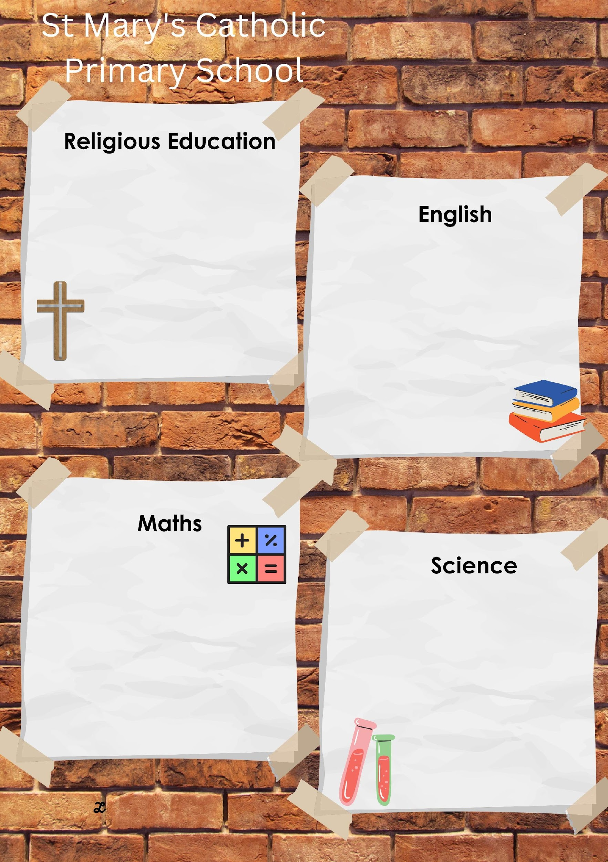
Summer 1 in Year 1
LIVE LOVE BELIEVE
This term will be learning all about Easter and the resurrection. We will also explore what the Easter candle represents and to find out what the disciples did after Jesus rose from the dead.
We will also be exploring the Religion of Hinduism.
The key scriptures we will study are:
Matthew 28:1-10 The Resurrection
Acts of the Apostles 2:14-36 Peter addresses the crowd

As part of our English we will be reading text around Animals .
The main focus of the term is to secure the use of a capital letter and full stop within our writing, using them consistently. We will be working on joining and sequencing our ideas so we have clear start, middle and end in different forms of writing. We will be refining our handwriting skills in preparation for Year 2. Spelling practise will remain the same and an increased focus will be on applying their phonic knowledge into our writing.
We will continue and work on the preparation for the phonics screens. I will discuss with you if/when you child needs to do anything additionally in order to support this.

In Maths we will revisit all the strands we have already covered but, in more detail, deepening our understanding and reasoning. We will have a greater focus on number fluency around the number system and securing simple number facts. Included is a chart of the number facts children should be fluent with. We will be working on money, factions (1/2 and ¼) and time (o’clock and half past).

In science this term we are learning all about plants. We will look at common garden plants and plants and flowers we consider as weeds. We will be looking at the flowers environment and whether they have been put there by a natural means or had human intervention. We will also be labelling parts of a plant and understand the function of the parts.

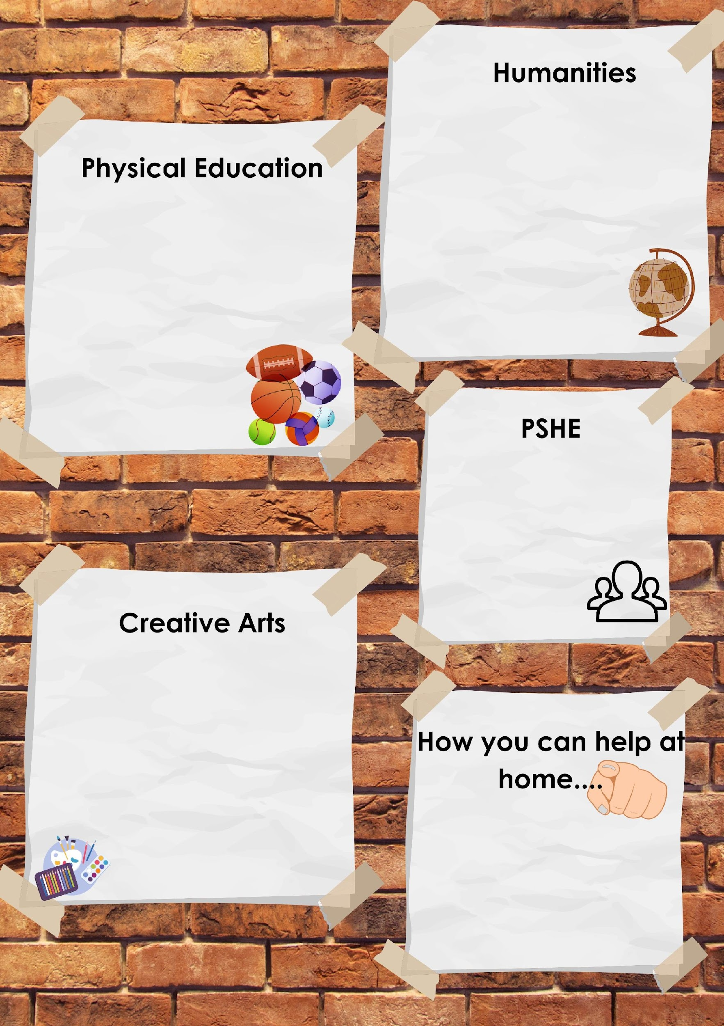
LIVE LOVE BELIEVE

The focus of our PE lessons this half term is:

Hit, Catch and Run

Our PE day this term is Friday

Please make sure that we have the correct clothing and footwear for these lessons.

This half term we will be completing a Geography topic based on where we live and what we environment looks like. We will be thinking about where people live and learning how to identify this on a map. We will be using maps to identify human and physical features. At the end of the unit we will undertake some field work around our local area.

In PSHE the children are looking at themselves and understanding what they need to do to stay healthy. They will also be looking at their own skills and what makes them unique. We will look at how diseases/viruses are passed to each other.
Art – This term we will be looking at Digital Art. We will explore different artists. Use photos we have taken to create some of our own art using digital images.

Reading at least 3 times a week with your child – allowing them to become fluent and confident readers is key!
Phonics – Practice the sounds sent home everyday and make connections with this and the reading of words.
Formation of letters and presentation.
Number fluency and simple addition and subtraction facts.

