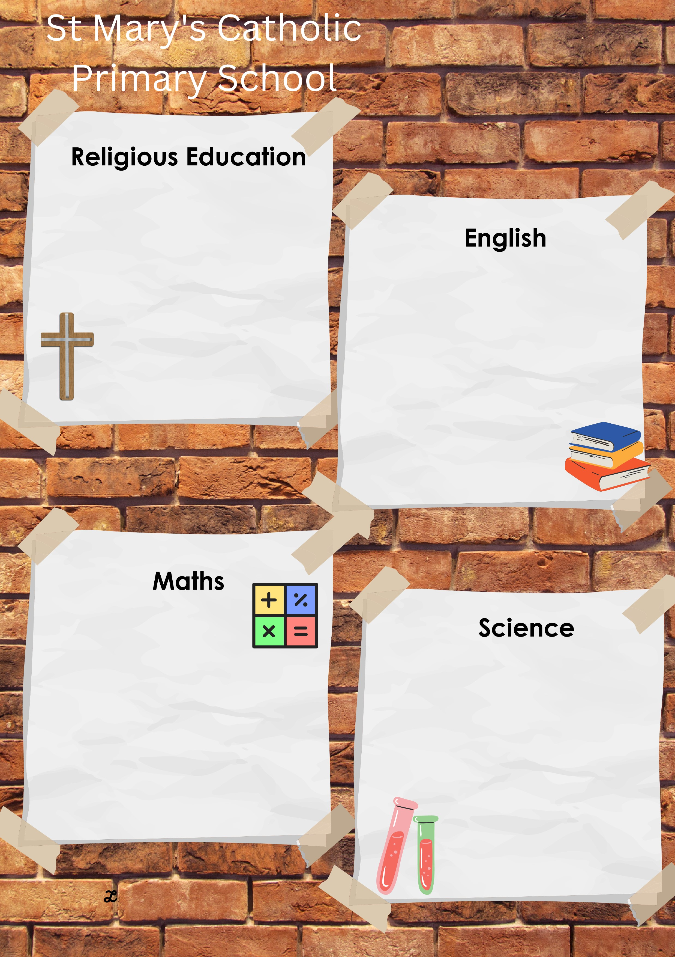
This half term we will be focusing on multiplication and division and will
be working on counting reliably in
2s, 3s, 5s and 10s from zero.
We will be solving addition and subtraction problems involving money and measures.
We will also be learning about fractions of shape and quantities.
Our work in capacity will involve estimating and measuring in millilitres and solving word problems.
.

This half term we will be reading:
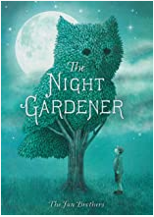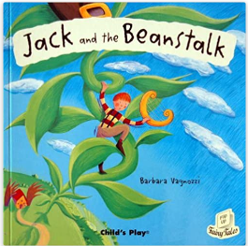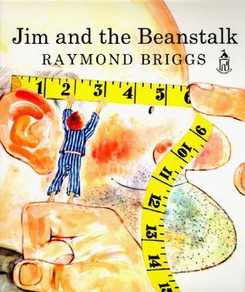
and we will be writing a recount and then using our skills to write our own fairy tale. We will be using expanded noun phrases in our descriptions and working on using commas between adjectives.
This half term we will be focusing on animals including humans and will learn that animals, including humans, have offspring which grow into adults. We will also find out about and describe the basic needs of animals, including humans, for survival (water, food and air).

We will learn how to describe the importance of exercise, eating the right amounts of different types of food, and why hygiene is so important.

This term will be learning all about the Easter story. We will found out about how Jesus rose from the dead and appeared to his disciples and we will find out why the disciples were surprised by the resurrection of Jesus.

The key scriptures we will study are:
Luke 24:1-12 (Resurrection account)
John 20:1-18 (Resurrection account)
John 20:24-29 (Doubting Thomas)

LIVE LOVE BELIEVE
Summer 1 in Year 2
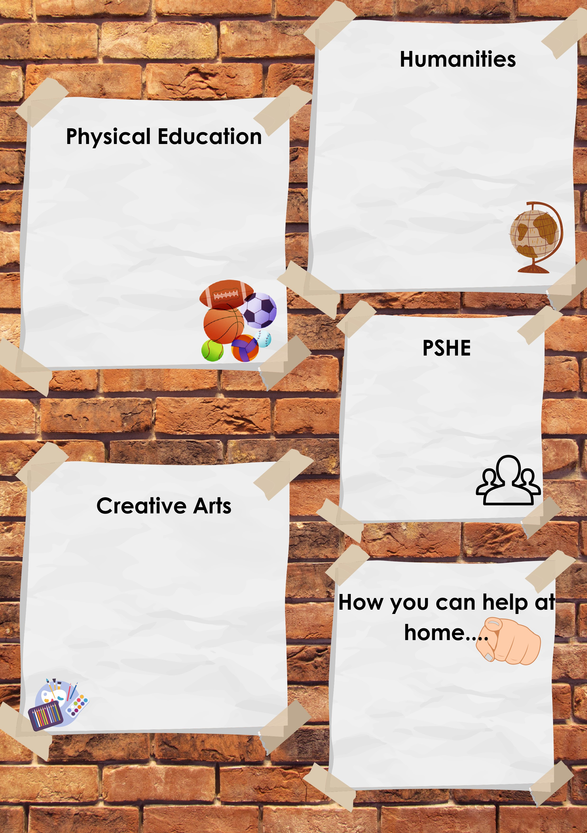

Reading at least 3 times a week with your child – allowing them to become fluent and confident readers is key!
Spelling – Practice spellings of high frequency words everyday.
Personal development – encourage impendence by packing their own bag and making sure they have everything they need for school.

Music will be led by Mrs Moore this term and will focus on creating different sounds.
In Art we will focus on Collage
We will be using different materials to collage a foreground and background We will overlay with oil pastel.

The focus of our PE lessons this half term is:
Send and receive
We are learning to track the path of a ball over a net move towards it. net. We will begin to hit and return a ball with some consistency. We will play modified games with throwing, catching and sending it over a net.
Please make sure that we have the correct clothing and
Footwear for these lessons.
PE lessons will be on Thursday.

Following the life to the full curriculum, we will be focusing on will learn about the different communities that they are part of, both local and global. They will think about what it means to belong to a community and the rights and responsibilities that come with it. Children will also learn that how they act can help or harm their communities.
This half term we will be learning all about our local Geography through a study called “Australia Vs The Isle of Wight”. We will be comparing both Islands and seeing what is similar and different to the human and physical Geography of these two places.
We will be finding out the answers to the questions:
How is the Isle of Wight similar to Australia?
What is the weather like on these two islands?

LIVE LOVE BELIEVE

