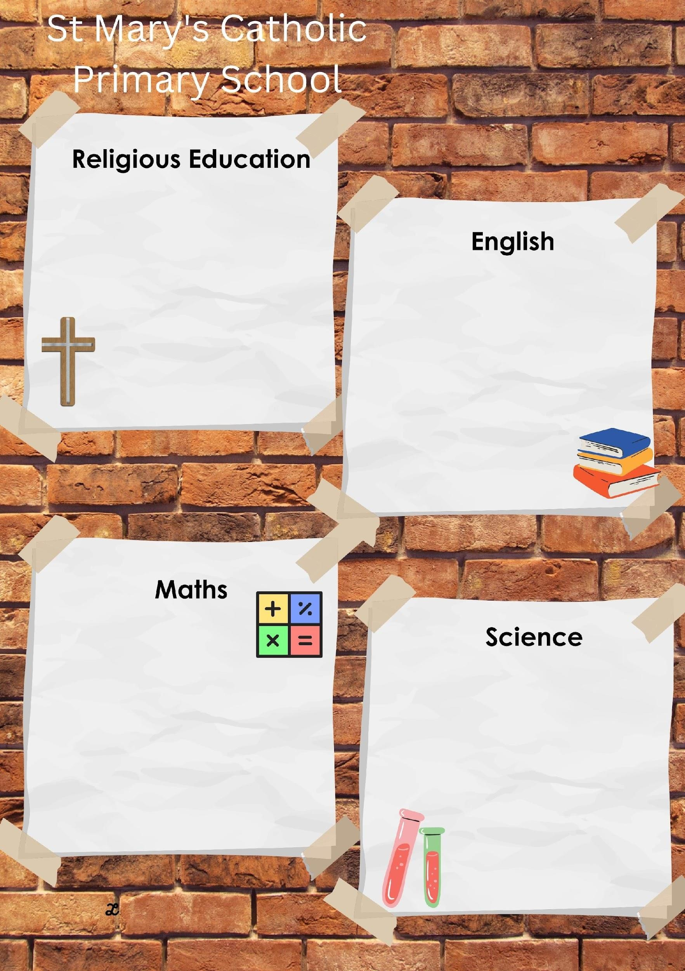

Spring 2
in EYFS

LIV
E
L
OV
E B
EL
IE
VE

This half term will be learning all about Christmas, It
provides an opportunity for the children to explore the
Christmas story and become familiar with the people
involved, the
location and the response to the Birth of
Jesus. There are opportunities to articulate and visualise
the first Christmas. All the activities will involve lots of
discussion and role
-
play.

We will also be
learning

about

Revelation,
introducing the role of the
Church in getting
to know God
.

The key scriptures we will study are:

Matthew 1:18
-
25
The Birth of
Jesus

Luke 2:1
-
20
The Birth of Jesus
-

Shepherds

Lk 1:26
-
38

–

The Annunciation

Matthew 14: 13
-

21
–

Feeding of the five thousan
d

This half term we will be reading:

This half term we

will be focusing
on numbers to 10.

We will be working on the following
skills through adult led activities and
within our continuous provision:

Mass and Capacity

Making pairs

Length and Height

Time and Measuring

Comparing numbers

3
D Shapes

Patterns

real life, everyday scientific

Focusing on the work of David Attenborough.

Jaspers Beanstalk
Whatever Next!
Look Up!
The Way Back Home
We’re Going on an Egg Hunt
Spring 2
In EYFS
We will be looking at:
Plants
Growth
Food
Weather
Space
Our theme this half term is
“Our World”
In Maths, we will be learning how about the composition of 9 & 10.
We will recognise, write, count, order, and subitise numbers up to 10.

We will also explore 2D and 3D shapes, understanding their properties, and recognising them in our environment.
We will be exploring and learning about Holy Week and Easter. We will talk about the stories relevant to these themes and reflecting on traditions that happen during these times.
This half term, we will be reading:
These stories will influence our continuous provision, develop our vocabulary and story-telling skills, and provide learning moments in our play.
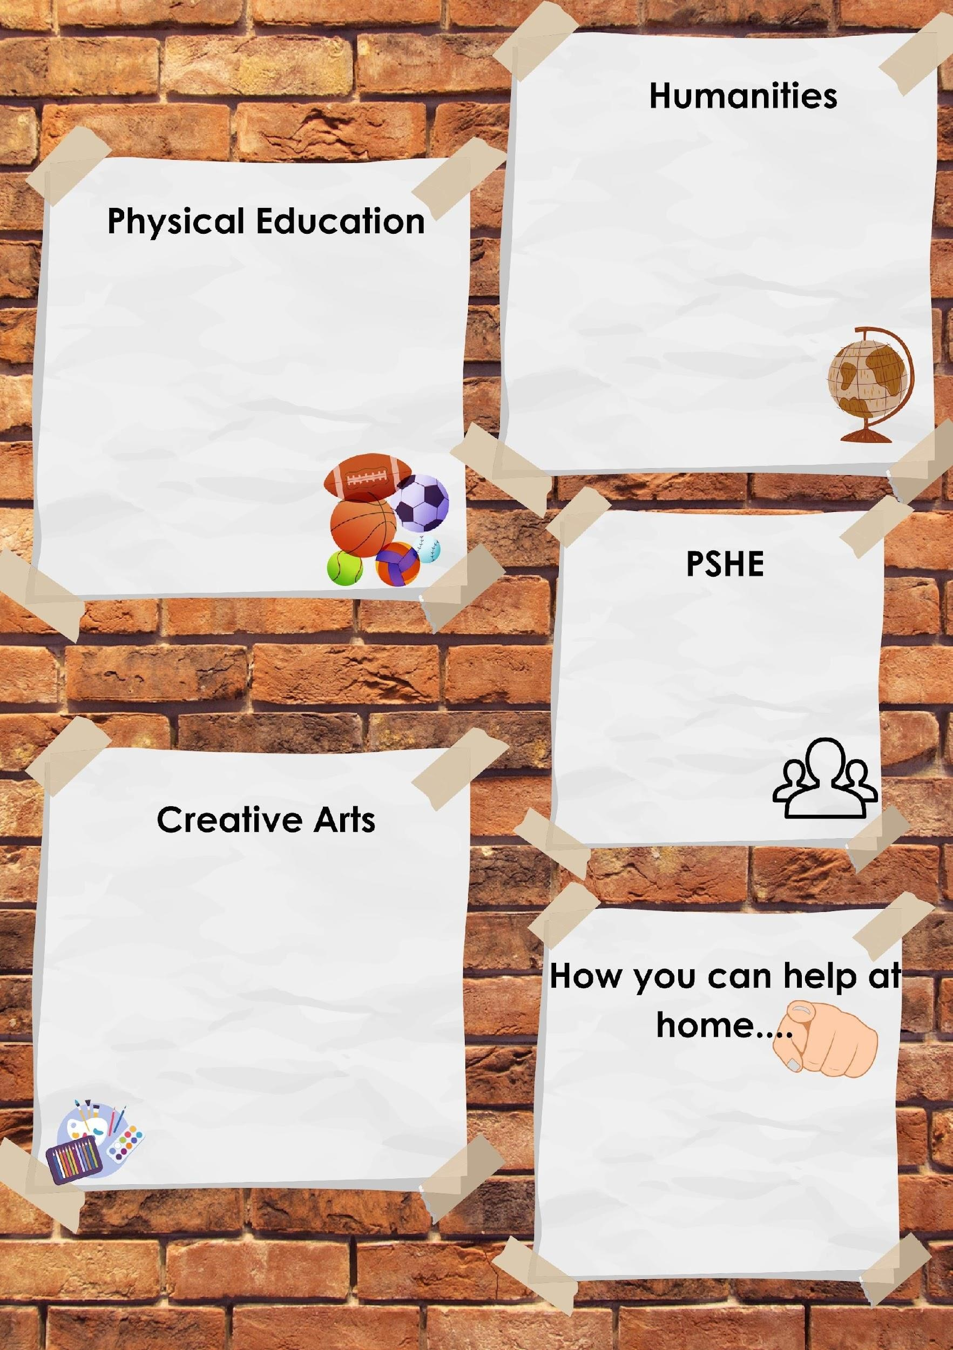

LIV
E
L
OV
E B
EL
IE
VE

The focus of our PE lessons this half term is:

Indoor: We wil
l be launching into Dance!

Outdoor: Multiskills
–

We will practice our

Multi-skills sessions every Thursday
morning to develop our gross motor skills, balance
And co-ordination

PE Days: Thursday and Friday
–

children
should
come to school in their PE kits which they will
stay in for the whole day.

This half term we will be learning all about the
children with our ‘Animals i
n Action
’ topic!

Extinct!
–

We
will d
iscuss animals that have
become extinct.

Night at the museum!
–

We
will
sequence the story
using pictures and props.

We will
discuss animals from different countries.
Why
they are

best suited to that habitat.

Fur coat,
camouflage etc.

We will t
alk about the change of season

-

).
(
winter to spring

Following the life to the full curriculum, we will
be focusing on the module called
:
CREATED
TO LOVE OTHERS
.

UNIT 1: RELIGIOUS UNDERSTANDING

Role model

UNIT 2: PERSONAL RELATIONSHIPS

Who’s who?

You’
ve got a friend in me.

Forever friends.

UNIT 3: KEEPING SAFE

Safe inside and out.

My body. My rules.

Feeling poorly.

People who help us.

Our

Art focus this year will be to develop our
artistic knowledge and skills through adult led
activities and daily continuous provision.

Art is promoted using:

●

Access to art and mark making
materials throughout the continuous provision.

●

Large
-

and
small
-
scale painting,
collage and junk modelling materials are
available.

●

Traditional and non
-
traditional
drawing and writing tools.

●

Self
-
.

Reading
at least

3
times a week with your
child
–

allowing them to become fluent and
confident
t readers is key!

Talk to your children
–

help them to
understand the world that we live in!

Personal development
–

keep working on
being independent with clothes and shoes.

This half term we will be focusing on drawing, painting and colour mixing (light to dark, primary to secondary)
We will be studying and taking Inspiration from the Artists Yayoi Kusama and Georgia O’Keefe and trying to recreate their famous pictures!

We will also be answering the following questions:
How can I change colours?
How do I keep brushes clean when colour mixing?
What effects can I make with my colour choices?
Mixing primary colours together to make secondary colours.

We will focus on learning about personal relationships, including friendships and then look at how to keep ourselves safe, with a focus on people who help us when we are poorly.

