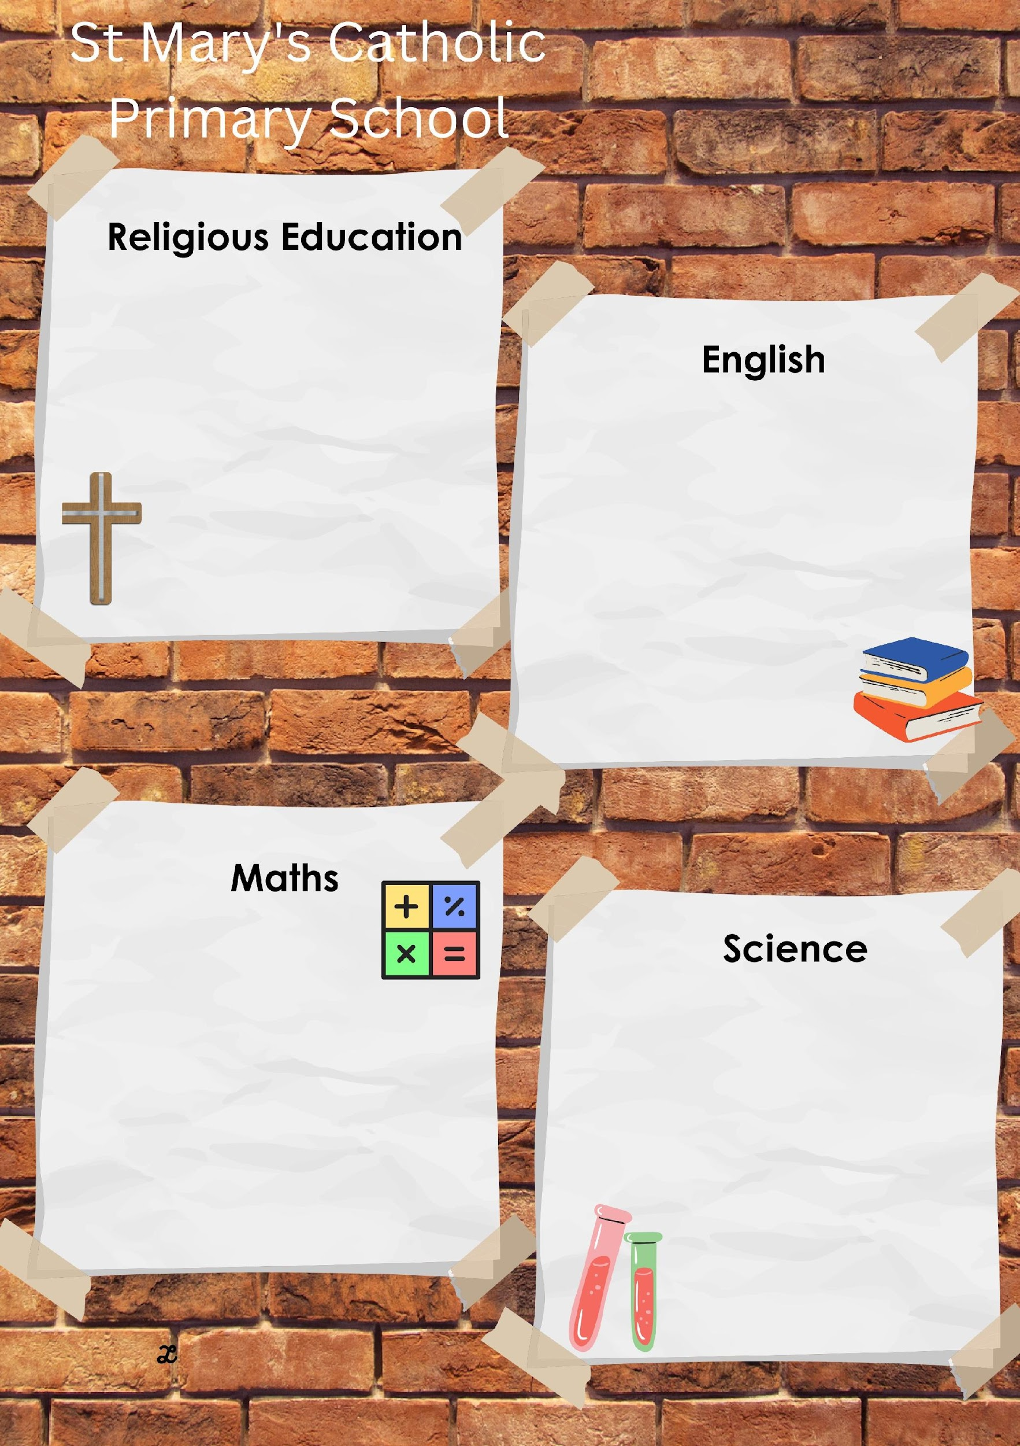
Summer 1 in Year 3
LIVE LOVE BELIEVE
This term will be learning all about Easter and that this is a liturgical season which lasts for fifty days. We will explore the symbolism of Easter and begin to understand that after the resurrection, the disciples became aware once again of being in the presence of Jesus.

The key scriptures we will study are:
Matthew 28: 1 – 10 (Easter Story)
John 21: 1-14 (Breakfast on the shore)
Matthew 14: 13-21 (Feeding of the 5000)

This half term we will be reading:

and will be writing our own character descriptions and narrative using the book at a model. We will be developing our use of fronted adverbials and the use of nouns and pronouns.
This half term we will be focusing on multiplication and division and developing using arrays as a grid (rather than dots). We will focus on counting in multiples of 3 and 4 from zero and will derive, recall and use multiplication and division facts for 3 and 4 multiplication tables
We will also solve problems including missing number problems involving multiplication and division, recording solutions with a range of representations to include number-lines, bar-models, and arrays.

This half term we will be learning about forces and magnets and will compare how things move on different surfaces. We will carry out our own experiments to notice that some forces need contact between two objects, but magnetic forces can act at a distance. We will observe how magnets attract or repel each other and attract some materials and not others.
We will then compare and group together a variety of everyday materials on the basis of whether they are attracted to a magnet, and identify some magnetic materials and describe magnets as having two poles

We will make predictions on whether two magnets will attract or repel each other, depending on which poles are facing.

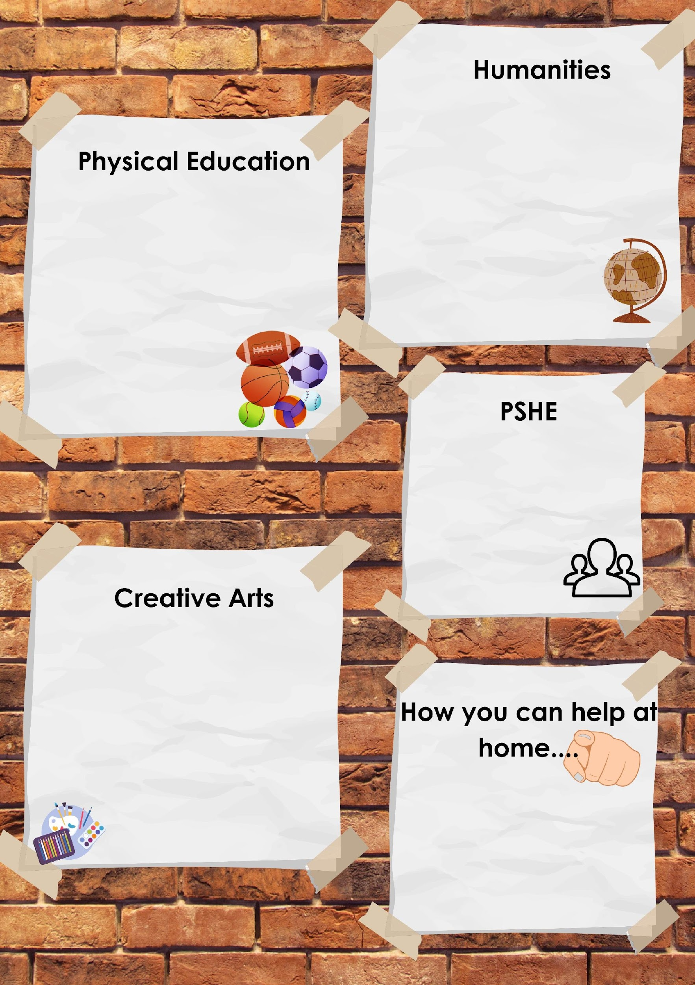
LIVE LOVE BELIEVE

The focus of our PE lessons this half term is:
Swimming at Waterside pool.
The purpose of the swimming course is to help non-swimmers learn how to swim and to support more experienced swimmers in enhancing their skills and techniques.
Make sure your child has everything they need for their swimming session!

This half term, our Geography focus will be on Earthquakes and Volcanoes.
We'll be exploring fascinating questions such as:
What causes a volcano to become active?
Where in the world can volcanoes be found?
Why don’t we have volcanoes on the Isle of Wight?
And why do people choose to live near volcanoes?

Following the life to the full curriculum, we will be focusing on the module called “a community of Love”.
We will learn that:
God is love as shown by the Holy Trinity – a communion of persons supporting each other in their self-giving relationship.
The human family reflects the Holy Trinity in mutual charity and generosity.

In Art this half term we will identify the techniques used by different artists. We will focus on digital images and combine them with other media in art. We will compare the work of different artists. We will also recognise when art is from different cultures and historical periods.
The skills we will be developing are:
use tools such as text, collage, filters and adjustments to alter our ‘post’.
experiment with the use of templates.

Reading at least 3 times a week with your child – allowing them to become fluent and confident readers is key!
Maths – Multiplication facts and the corresponding division calculations.
Personal development – Start to develop independent reading and research for other areas of the curriculum.

