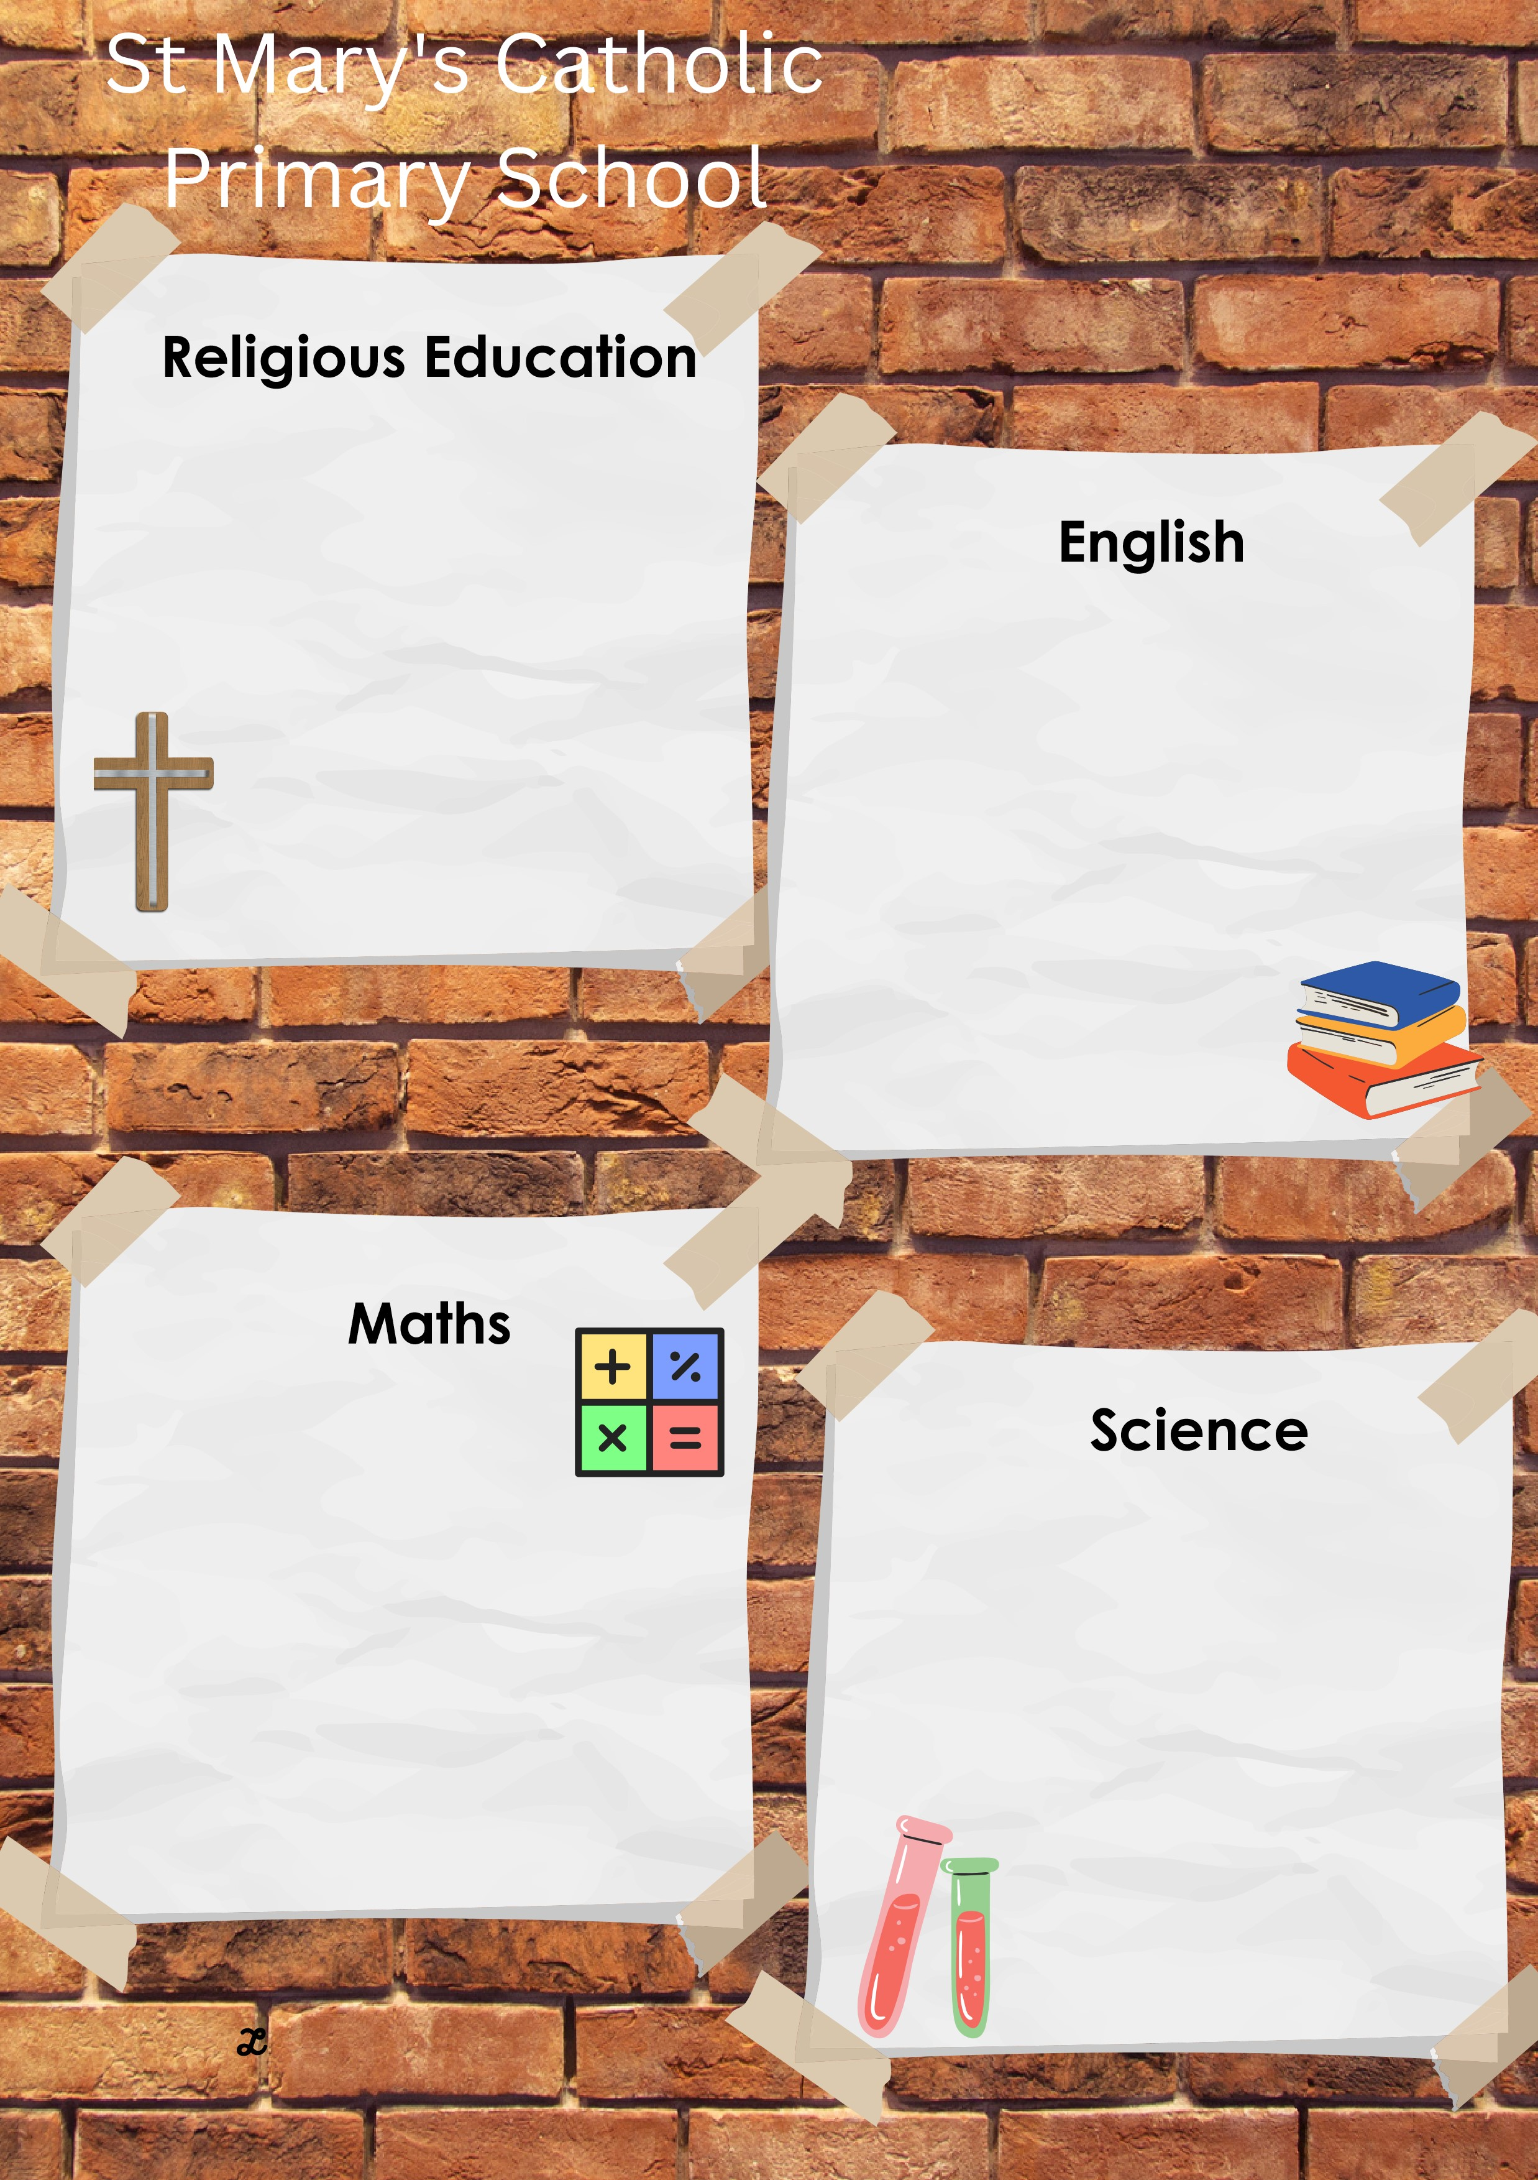
This half term we will be focusing on states of matter. We will compare and group materials together, according to whether they are solids, liquids or gases

We will observe that some materials change state when they are heated or cooled, and measure or research the temperature at which this happens in degrees Celsius (°C)

Lastly, we will identify the part
played by evaporation
and condensation in the water cycle and associate the rate of evaporation with temperature.

This half term we will be continuing to perfect our fluency with our times tables, ready for the multiplication check in June!
We will also be using this vital skill to help us with understanding division.
After we have mastered this, we will move on to learning about geometry and will look at using statistics with our reasoning and problem solving.

This half term we will be reading:
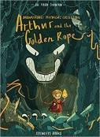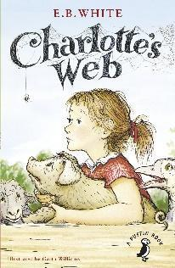
and we will be writing a character description and a detailed recount using these books. We will be developing our writing skills using determiners, pronouns and adverbial phrases.
This term will be learning all about Easter with a focus on the risen Jesus, shown through the Ascension and other stories.
The key scriptures we will study are:
Resurrection Accounts
Matthew 28: 1 – 10
Mark 16: 1-5
Luke 24: 1-43
John 20: 1-12
Luke 24: 13-35 (Road to Emmaus)
Ascension Accounts
Mark 16: 19-20
Luke 24: 50-52
Acts 1: 6-11

LIVE LOVE BELIEVE
Summer 1 in Year 4
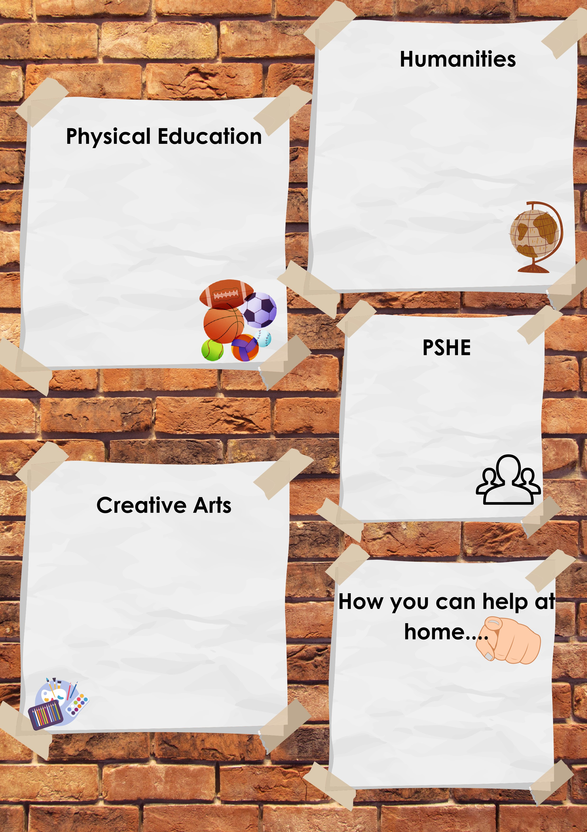

Reading at least 3 times a week with your child – allowing them to become fluent and confident readers is key!
Daily times table practice – we need to be confident with knowing the facts and not trying to work them out on our fingers!
Having discussions about how to keep yourselves safe

Our Art focus this half term will have strong History and Geography links and will develop the following skills:
- Show facial expressions and body language in sketches and paintings.
- Use marks and lines to show texture in my art.
- Use line, tone, shape and colour to represent figures and forms in movement
- Show reflections in my art.
- Print onto different materials using at least 4 colours.
- Sculpt clay and other mouldable materials.
- Integrate my digital images into my art.
- Experiment with styles used by other artists.
- Explain some of the features of art from historical periods.

The focus of our PE lessons this half term is:
Indoor: Gymnastics. During these lessons, we will work with a partner to create, repeat and improve a sequence with at least three phases.
Outdoor: Athletics. We will continue to develop our physical activity lessons by sprinting over a short distance, throwing and jumping in different ways and hitting a target successfully.
Please make sure that we have the correct clothing and footwear for these lessons.

Following the life to the full curriculum, we will be focusing on the module called “created to love others”. Lessons will focus on keeping safe and learning about online safety, understanding drugs, alcohol and tobacco and first aid.
This half term we will be learning all about the Vikings and their impact on Britain!
We will be finding out the answers to the questions:
Were Vikings really vicious?
What Impact did the Vikings have on Britain and the Isle of Wight?
How has Britain changed since the Vikings?

LIVE LOVE BELIEVE

