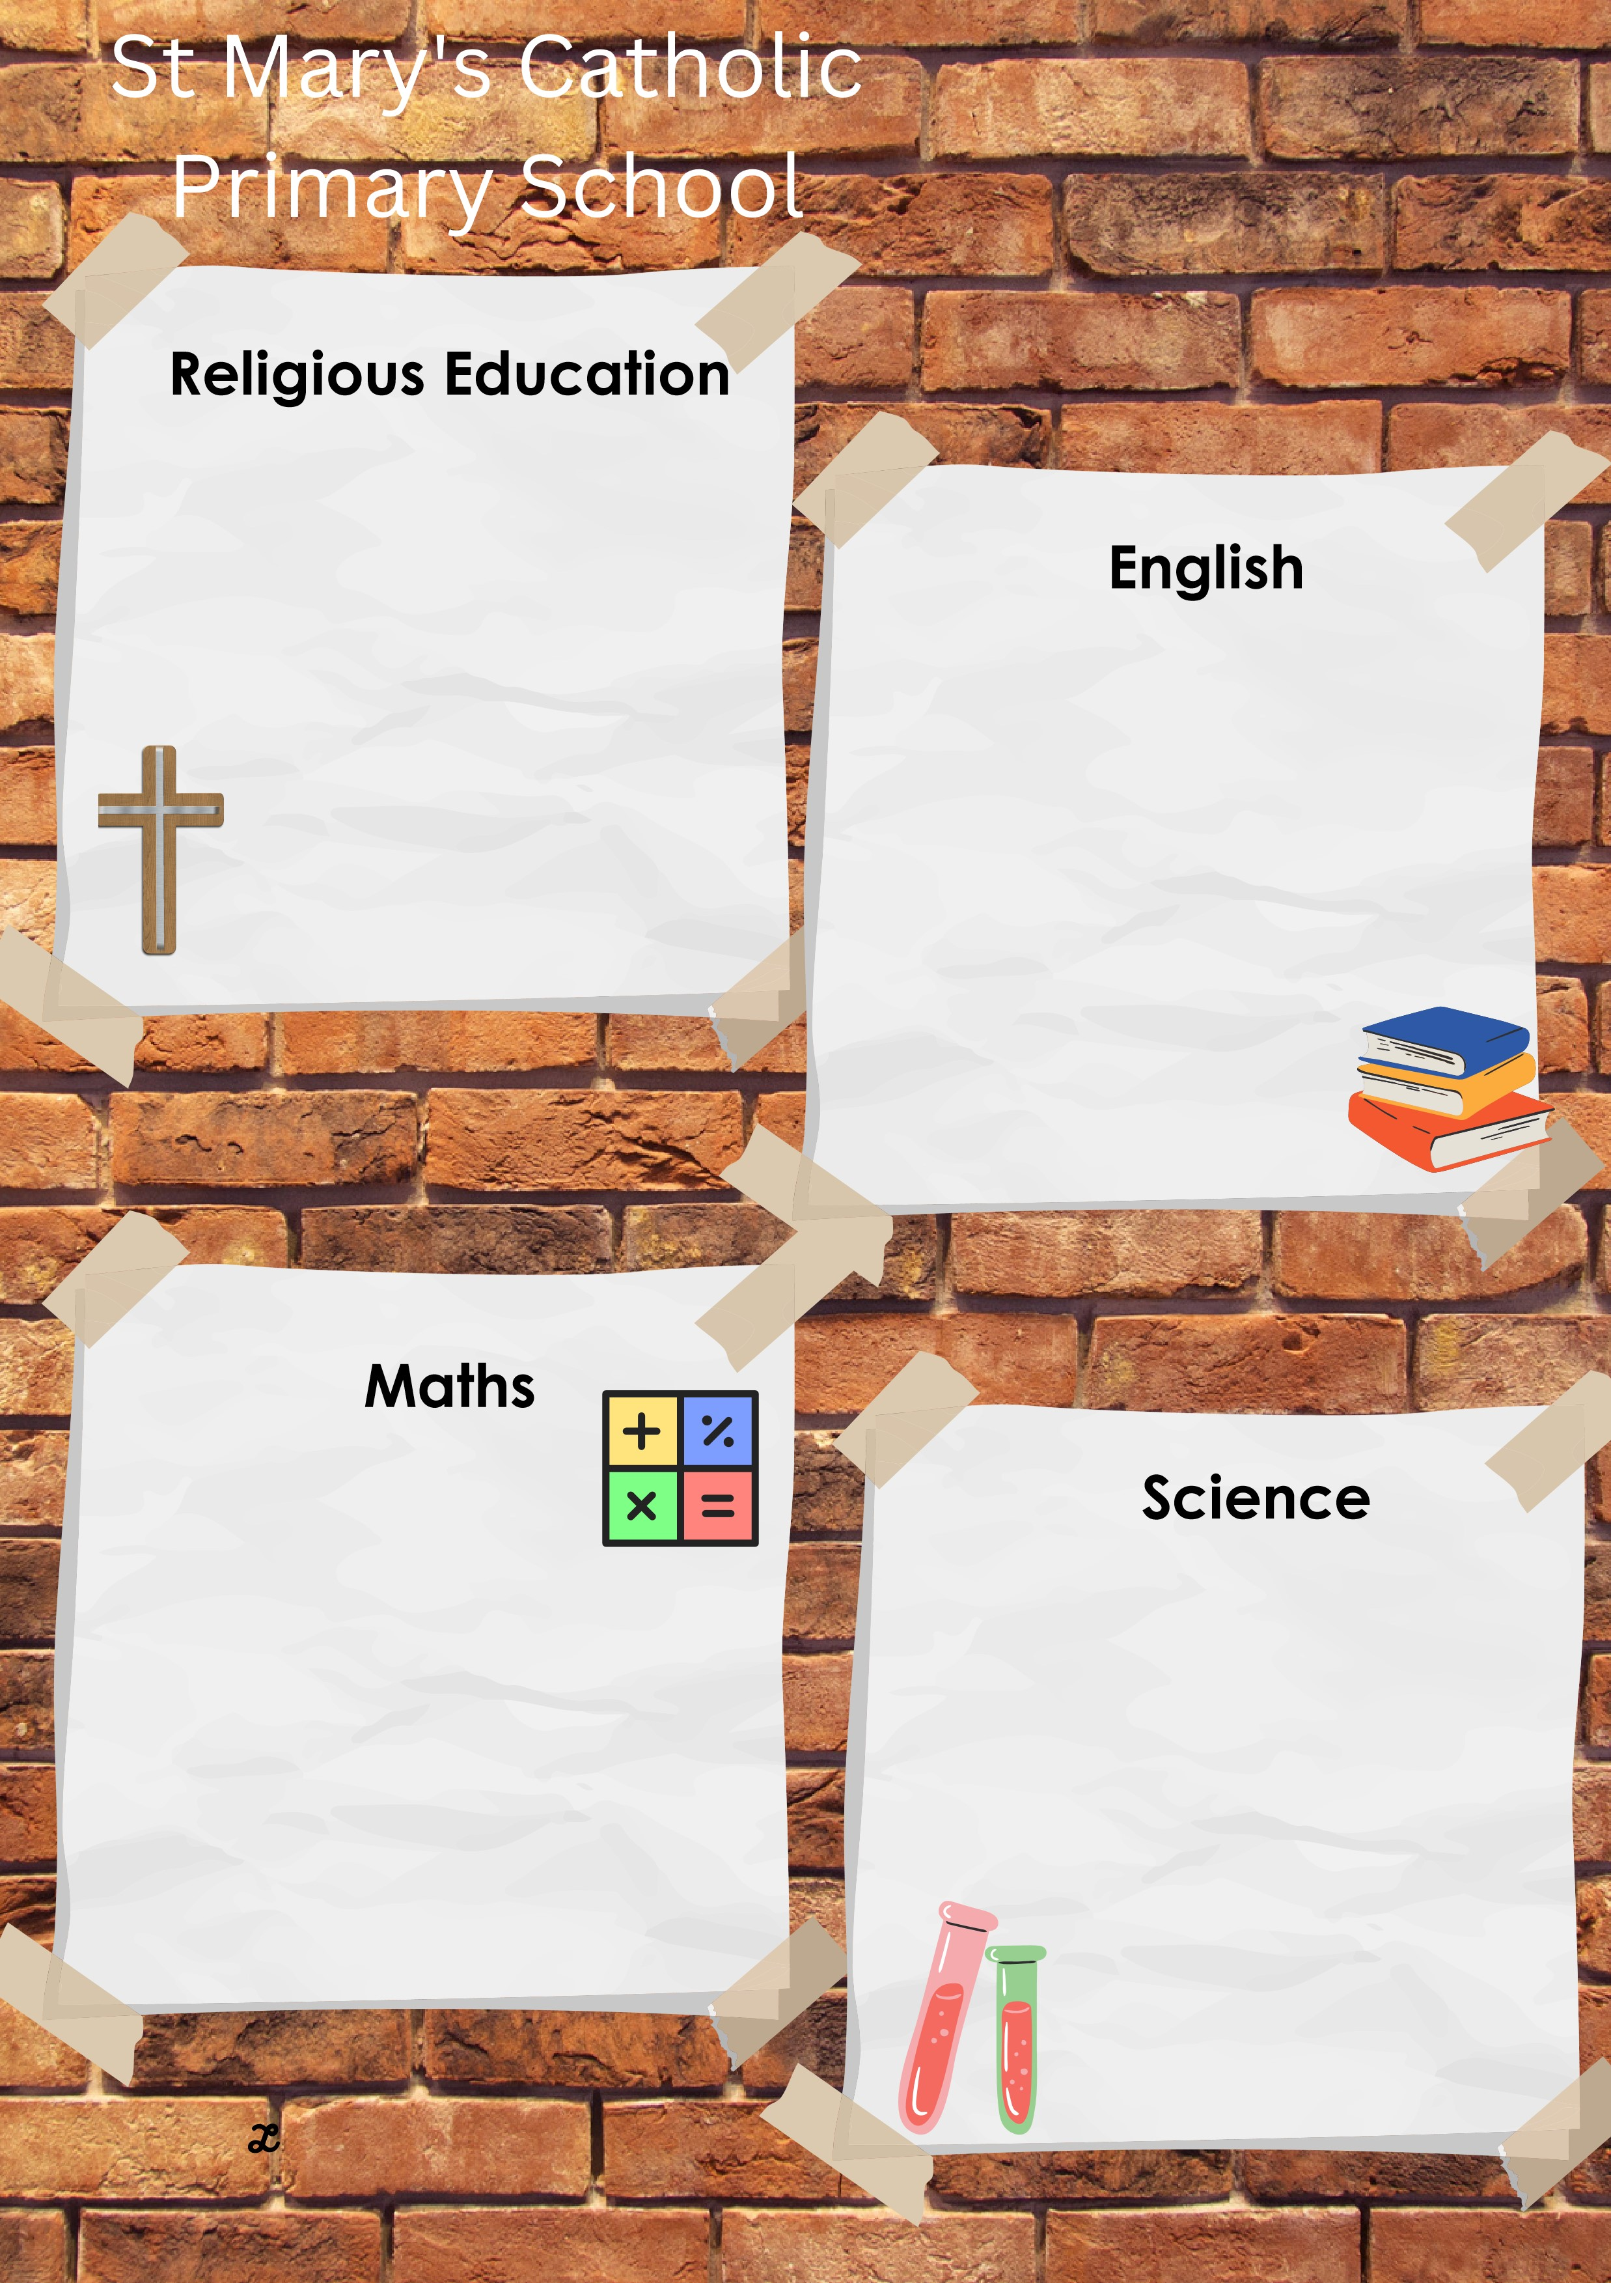
This half term we will be focusing on multiplication and division, including square, cube and prime numbers.
We will then move on to learning about geometry, with a focus on position and direction within problem solving.
We will also be consolidating our addition and subtraction knowledge using formal written methods and statistics.

This half term we will be reading:
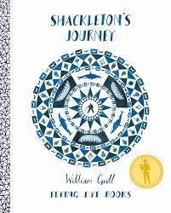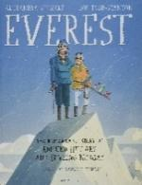
We will be writing a recount of Shackleton’s amazing journey and a letter using formal language. We will develop our skills of using language for formal speech and applying commas for parenthesis.

This half term we will be focusing on animals including humans, with a focus on describing the changes as humans develop to old age.

We will be carrying out scientific research to compare the gestational periods of animals and humans.

We will then move on to starting to understand the basic concepts of puberty and how bodies change.

This term will be making connections between the events of Holy Week, Easter and the liturgical life of the Church. We will develop a detailed understanding of the symbolism of Easter, as well as the beliefs that lie behind it. The story of Lazarus will help us to explore reaction to and the effect of the resurrection. We will also explore The Hindu religion in the multi-faith element of our journey.

The key scriptures we will study are:
Easter Vigil Service
John 11: 17-44 (Lazarus)

LIVE LOVE BELIEVE
Summer 1 in Year 5
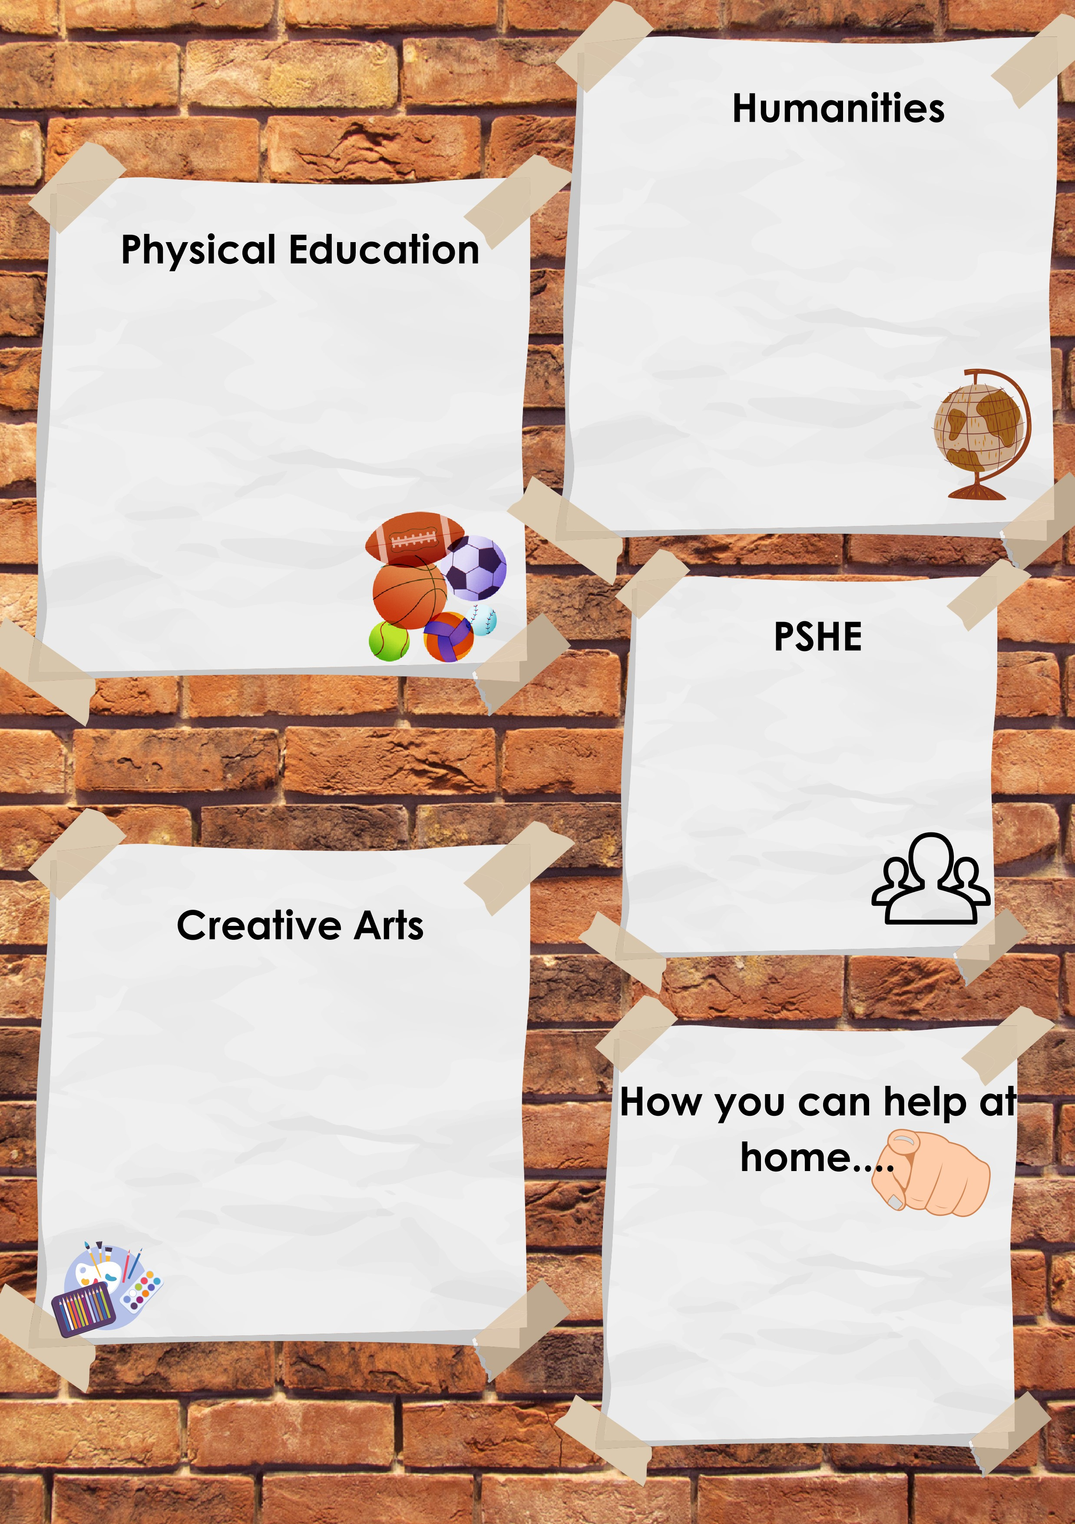
Following the Life to the Full and SCARF curriculums, we will be studying a unit called, ‘Being my Best’.
We will look at our talents and how, with perseverance, we can acquire new skills.
We focus on independence and responsibility and how this might change as we get older.
This half term in History, we will be learning all about Crime and Punishment through the ages and explore how this has changed in Britain through time.
We will be finding out about Roman crime and punishment and its legacy on the current legal system in Britain.
We will compare Crime and punishment in Roman times with Anglo-Saxons.
We will study crime and punishment in Tudoe times and how this changed Britain and then focus on the Victorian period including looking at the Isle of Wight link and how children were treated.

Reading at least 3 times a week with your child – allowing them to become fluent and confident readers is key!
Maths -multiplication and corresponding division facts.
Personal development – complete homework and research independently, especially for things they find difficult to become their own problem solvers.

Our Art focus this half term we will be creating Digital Art.
Using ‘Sketchbook’, we will ‘facepaint’ over our own image and focus on altering these images to create masks. We will use the Mexican day of the Dead for inspiration for patterns and colours.
We will also look at the work of Chris Milk and explore his work. We will then create our final piece using ourselves as a canvas.

The focus of our PE lessons this half term is:
Sailing:

At Sea View Yacht Club, we will build on previous sailing experiences and learn new skills.
This great opportunity improves self-confidence and gives children the chance to push themselves.
Please make sure that you have the correct clothing and footwear for sailing.

LIVE LOVE BELIEVE

