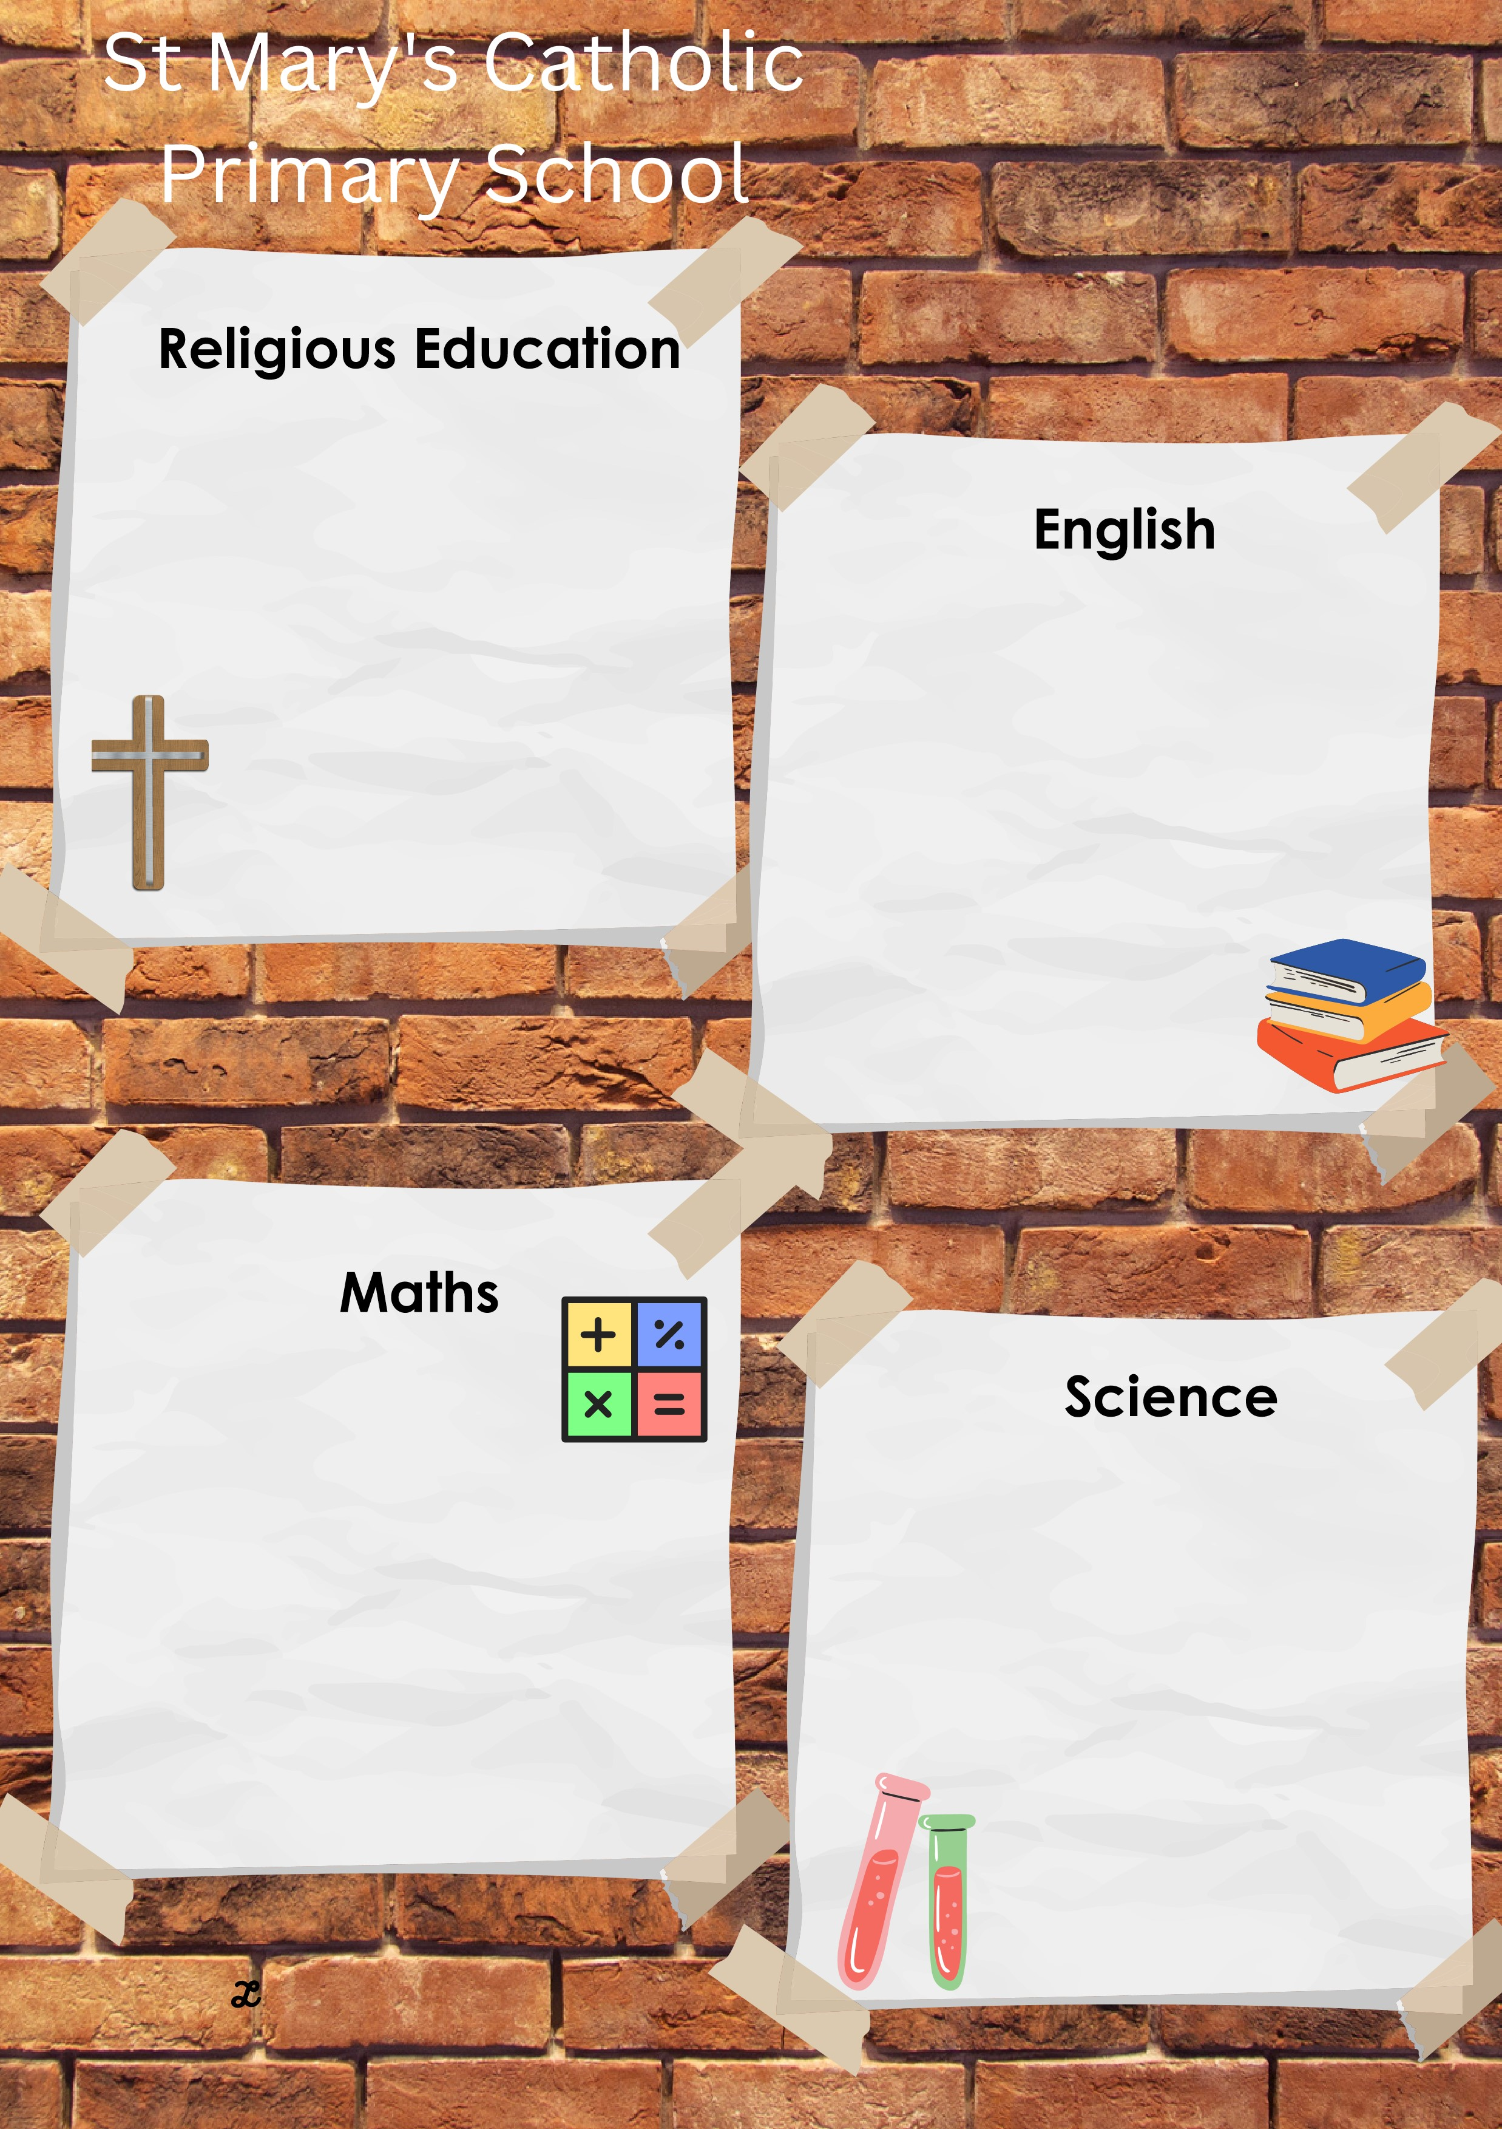
Easter
This unit provides opportunities to explore in real detail the events of the Easter season. This is achieved by examining the parallel accounts of the Gospels. The Christian beliefs in eternal life are explored through examination of Scripture and the Catholic funeral liturgy.
The key scriptures are:
John 20:19-29 (Doubting Thomas)
John 6:37-40 (Jesus and eternal life)
1 Thessalonians 4:13-18 (About those who have died.)

In the summer term, maths lessons will focus upon the following:

Preparation for SATs
6.12 Multiplication and divisions with squares, cubes and primes.
6.14 Fractions and equivalences
6.15 All 4 operations (whole numbers and fractions)

Light – How does light travel?
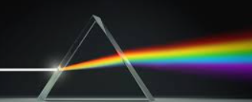

This half term we will be reading:
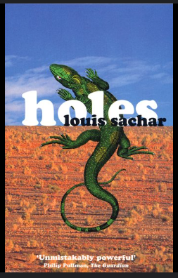
LIVE LOVE BELIEVE
Summer 1
in Year 6
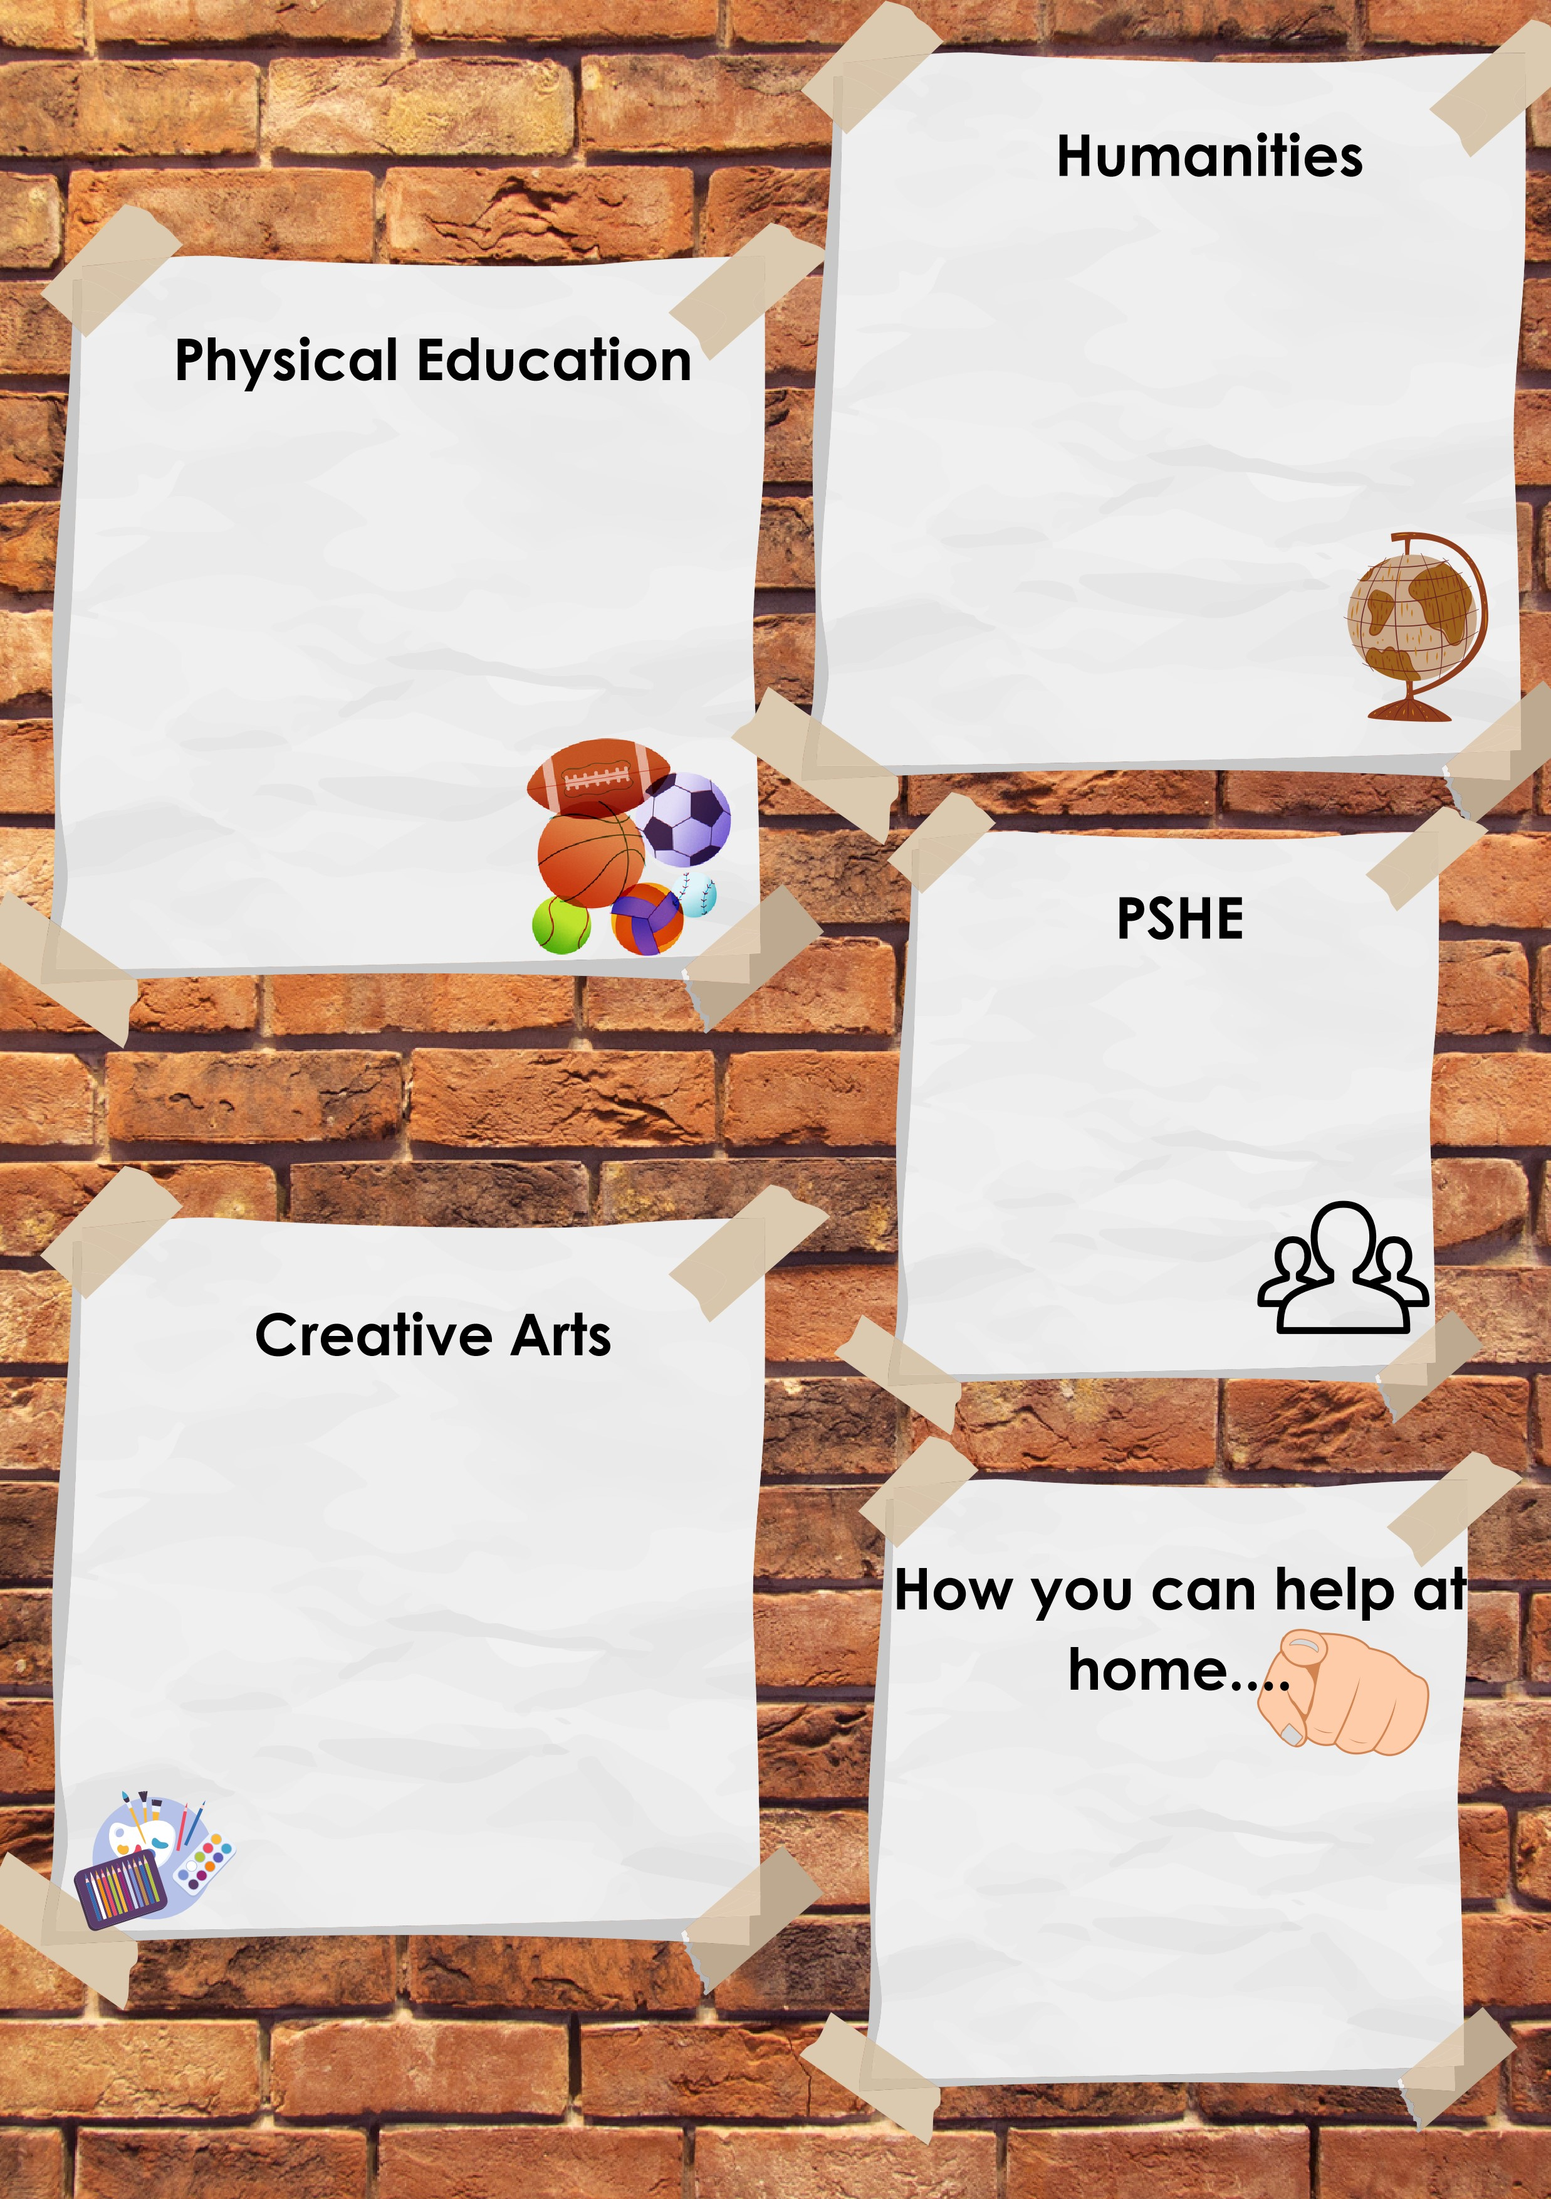
Reading at least 3 times a week with your child – allowing them to become fluent and confident readers is key!
Complete homework: Spelling & Grammar, Reading and Maths.
Personal development – To pack school bag independently with all necessary equipment for the day.

The focus of our PE lessons this half term is:
Athletics
Tennis
History:
Indus Valley Civilisation
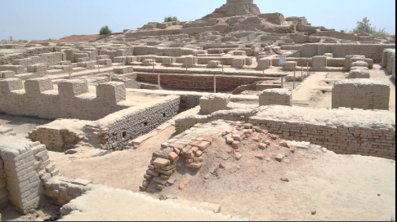

Digital Art


This half term we will be learning about:
UN right 8 –Identity
UN right 6 - Life, survival, development
UN right 34 - protection from abuse
UN right 24 - Health, water, food, environment
LIVE LOVE BELIEVE

